CSS BRITISH HISTORY · TOPIC 10 · QUESTION ANSWERS
Blair to Burnham (1997–2026)
Every past question on New Labour, the War on Terror, the financial crisis, David Cameron, Brexit and Lady Diana — answered in full, in simple words, with answer maps

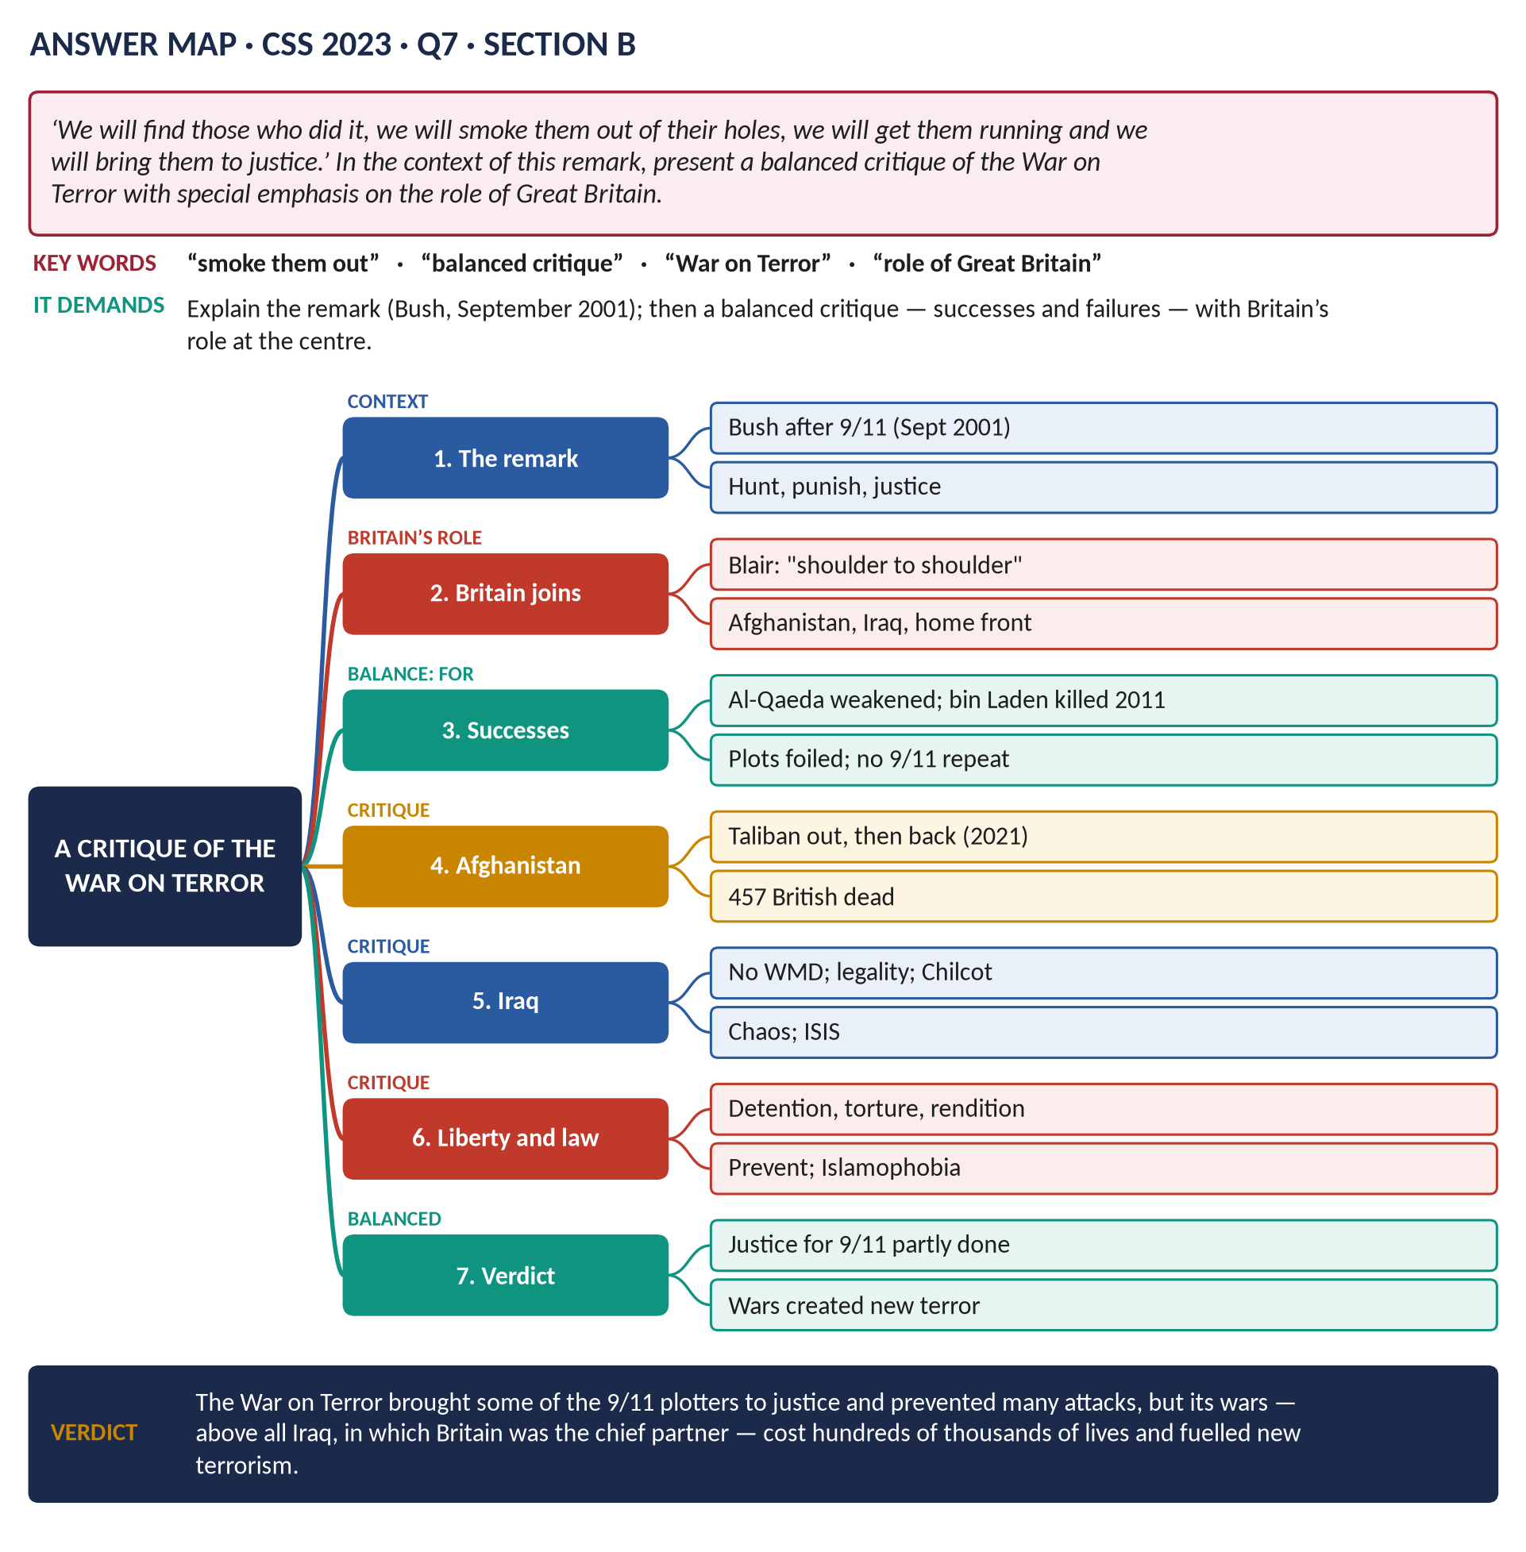
All 13 past items (2015–2026): eight full answers and five short notes (two set twice); the eight past MCQs solved; five predicted questions with outlines.
Topic 10 of 10 · companion to T10KB (the Knowledge Base)
Contents
HOW TO USE THIS · Updating the contents
Right-click the contents → Update Field → Update entire table, before saving as PDF.

How to Use These Answers 7
Answer 1 · New Labour: Thatcherism by Other Means, or a Distinct Project? 8
The model answer 9
Introduction 9
Limb 1 · How New Labour differed from previous Labour governments 10
(1) Ownership and the market 10
(2) The trade unions 10
(3) Tax and the economy 10
(4) Voters and image 10
(5) Foreign policy 10
Limb 2 · Thatcherism by other means? 10
(6) The case for continuity 10
(7) The case for a distinct project 11
Answer 2 · 1997–2012: Renewal or Unresolved Contradictions? 13
The model answer 14
Introduction 14
Constitutional reform 14
(1) Renewal 14
(2) Contradictions 14
Foreign policy 15
(3) Renewal 15
(4) Contradictions 15
International identity 15
(5) Renewal 15
(6) Contradictions 15
Judgement 15
Answer 3 · Blair's War on Terror and US–British Relations 17
The model answer 18
Introduction 18
Limb 1 · The salient features of Blair's policy 18
(1) Solidarity with America 18
(2) A moral, interventionist doctrine 19
(3) Afghanistan (2001–) 19
(4) Iraq (2003) 19
(5) Security measures at home 19
(6) Diplomacy and "hearts and minds" 19
Limb 2 · The effect on US–British relations 19
(7) A closer relationship 19
(8) British influence — real but limited 20
(9) The costs for Britain 20
(10) Long-term effects 20
Answer 4 · "Smoke Them Out of Their Holes": A Balanced Critique of the War on Terror 21
The model answer 22
Introduction 22
The remark and the aims 23
(1) What Bush promised 23
(2) Britain's role 23
Achievements 23
(3) "Smoking them out" — partly achieved 23
(4) Britain's contribution 23
Failures and costs 23
(5) Iraq — the central failure 23
(6) Afghanistan — a lost war 24
(7) Justice and values 24
(8) Terrorism at home 24
(9) Political costs for Britain 24
Answer 5 · How the Financial Crisis Plunged Britain into Recession, and How It Responded 26
The model answer 27
Introduction 27
Limb 1 · How the crisis caused recession 27
(1) The American origins 27
(2) Britain's vulnerability 27
(3) The banking crisis 28
(4) From banking crisis to recession 28
Limb 2 · How Britain responded 28
(5) The bank rescue (October 2008) 28
(6) Monetary policy 28
(7) Fiscal stimulus 28
(8) International leadership 28
(9) The coalition's response (from 2010) 29
(10) Results 29
Answer 6 · The Financial Crisis: Impact, Two Responses and Long-Term Effects 30
The model answer 31
Introduction 31
Part 1 · The impact on politics and society 31
(1) Politics 31
(2) Society 31
Part 2 · How the two responses differed 32
(3) Labour's response (2008–2010): stimulus 32
(4) The Conservative-led response (2010–2016): austerity 32
Part 3 · The long-term effects 33
(5) Of Labour's response 33
(6) Of austerity 33
(7) For British politics 33
Answer 7 · David Cameron's Foreign Policy, with Special Reference to the Middle East 35
The model answer 36
Introduction 36
General features 36
(1) "Liberal conservatism" 36
(2) Commercial diplomacy 36
(3) Aid and soft power 36
(4) Defence cuts and the "Iraq syndrome" 36
(5) Europe and Russia 36
The Middle East 37
(6) The Arab Spring (2011) 37
(7) Libya (2011) — his defining intervention 37
(8) Syria 37
(9) ISIS 38
(10) Iran 38
(11) The Gulf 38
(12) Israel and Palestine 38
(13) Afghanistan 38
Assessment 38
Answer 8 · The Advantages and Disadvantages of Brexit for England 40
The model answer 41
Introduction 41
The advantages 42
(1) Sovereignty and democracy 42
(2) Money 42
(3) Trade policy 42
(4) Regulatory freedom 42
(5) Immigration 42
(6) Agriculture and fishing 42
The disadvantages 42
(7) Trade with Europe 42
(8) The economy 43
(9) Immigration — an unexpected result 43
(10) The Union 43
(11) Influence and other losses 43
Analysis 43
Short Notes 45
Reforms under David Cameron (also 2025 Q8(c)) 45
Britain's Role in the War on Terror 45
Lady Diana (also 2026 Q8(b): Lady Diana Spencer) 46
Part Two — The Past MCQs, Solved 47
CSS 2024 · MCQ 10 47
CSS 2025 · MCQ 15 47
CSS 2025 · MCQ 18 47
CSS 2025 · MCQ 20 47
CSS 2026 · MCQ 11 48
CSS 2026 · MCQ 12 48
CSS 2026 · MCQ 13 48
CSS 2026 · MCQ 20 48
Part Three — Five Predicted Questions, with Outlines 50
Predicted 1 · "Assess the significance of devolution and the Good Friday Agreement for the United Kingdom." 50
Predicted 2 · "Evaluate the Blair government's domestic record, 1997–2007." 50
Predicted 3 · "Why did Britain vote to leave the European Union in 2016?" 50
Predicted 4 · "Discuss the political instability in Britain from 2016 to 2024." 50
Predicted 5 · "How did the Covid-19 pandemic affect British politics and society?" 50

How to Use These Answers
# | Paper | Question (short) | Answer
1 | 2025 Q6 | New Labour v previous Labour governments; Thatcherism or a new project? | Answer 1
2 | 2026 Q7 | 1997–2012: renewal or unresolved contradictions? | Answer 2
3 | 2021 Q8 | Blair's War on Terror; its effect on US–British relations | Answer 3
4 | 2023 Q7 | Bush's "smoke them out": a balanced critique of the War on Terror | Answer 4
5 | 2023 Q8 | How the financial crisis caused recession; Britain's response | Answer 5
6 | 2025 Q7 | The crisis: impact; Labour and Conservative responses; long-term effects | Answer 6
7 | 2016 Q7 | Cameron's foreign policy, with reference to the Middle East | Answer 7
8 | 2017 Q8 | Advantages and disadvantages of Brexit | Answer 8
9 | 2024 Q7(b) · 2025 Q8(c) | Short note: reforms under Cameron (set twice) | Short note
10 | 2026 Q8(a) | Short note: Britain's role in the War on Terror | Short note
11 | 2018 Q8(c) · 2026 Q8(b) | Short note: Lady Diana (set twice) | Short note

Every answer has: the question as set · its answer map · decoding the question · a model answer with numbered headings, figures and a verdict · why this answer scores.

Answer 1 · New Labour: Thatcherism by Other Means, or a Distinct Project?
THE QUESTION · CSS 2025 · Q6 · Section B · 20 marks
How did the policies of New Labour under Tony Blair differ from those of previous Labour governments? Was it a continuation of Thatcherism by other means, or did it represent a distinct political project?

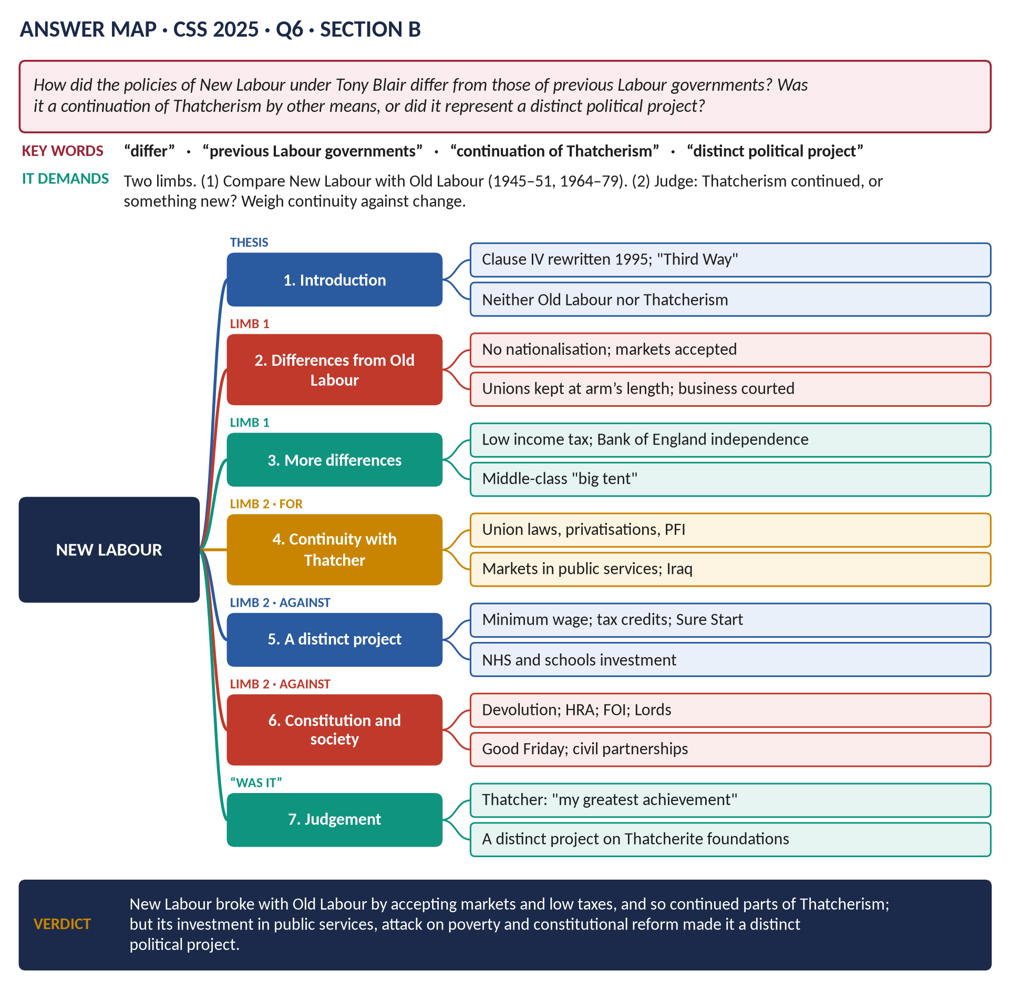
Figure 1 · The answer map for CSS 2025 · Q6 · Section B: every branch is one heading of the answer below.
DECODING THE QUESTION
Two limbs. (1) "How did the policies of New Labour under Tony Blair differ from those of previous Labour governments?" — compare with Attlee (1945–51) and Wilson/Callaghan (1964–79): ownership, unions, tax, spending, voters. (2) "Was it a continuation of Thatcherism by other means, or did it represent a distinct political project?" — weigh the evidence of continuity with Thatcher against the evidence of a new project, and decide.

The model answer

Introduction
New Labour was the name Tony Blair gave to the Labour Party he led from 1994 and took to three election victories (1997, 2001, 2005). It broke decisively with the Labour governments of the past — abandoning nationalisation, keeping the trade unions at arm's length and accepting low income taxes and the market economy. In doing so it kept much of what Margaret Thatcher had built. But New Labour was not simply Thatcherism with a kinder face: its investment in public services, its attack on poverty and its constitutional revolution made it a distinct political project — the "Third Way" — built on Thatcherite foundations.
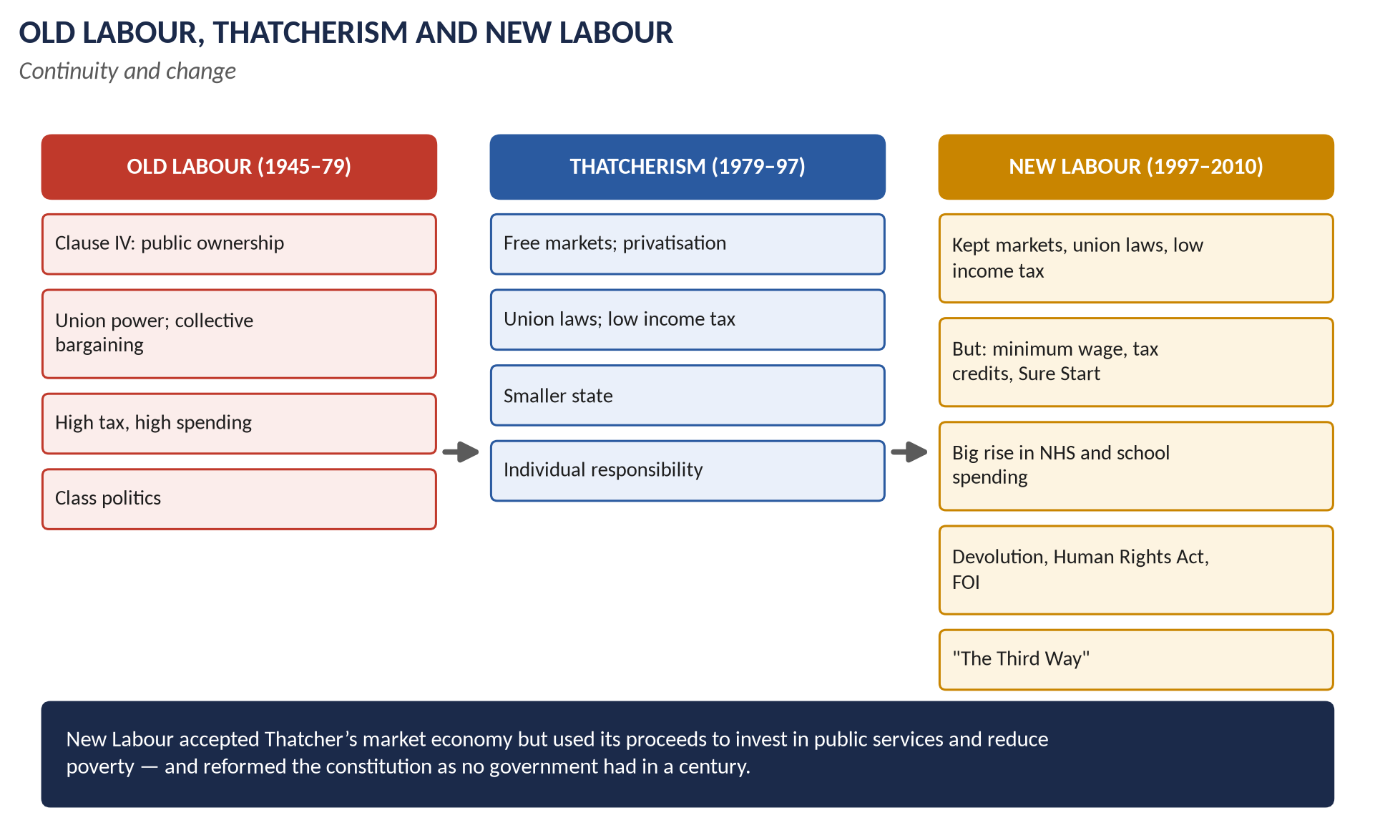
Figure 2 · Old Labour, Thatcherism and New Labour.

Limb 1 · How New Labour differed from previous Labour governments

(1) Ownership and the market
- Old Labour: Clause IV (1918) committed the party to common ownership; Attlee nationalised coal, railways, gas, electricity and steel (1945–51); Wilson renationalised steel (1967).
- New Labour: Blair rewrote Clause IV (1995) to praise "the enterprise of the market and the rigour of competition"; no privatised industry was renationalised; the Private Finance Initiative used private money to build hospitals and schools.

(2) The trade unions
- Old Labour: the unions founded and financed the party and were partners in government ("beer and sandwiches at Number Ten"; the Social Contract, 1974–79).
- New Labour: kept Thatcher's union laws; "fairness, not favours"; more money from business donors.

(3) Tax and the economy
- Old Labour: high, progressive taxes (top rates up to 83 per cent in the 1970s); demand management; frequent sterling crises (1949, 1967, 1976).
- New Labour: promised no rise in income tax; cut the basic rate; gave the Bank of England independence (1997); "prudence" and the fiscal rules; low inflation.

(4) Voters and image
- Old Labour: the party of the industrial working class.
- New Labour: a "big tent" — "Middle England", business, the aspirational; media management; the support of The Sun.

(5) Foreign policy
- Old Labour: often divided over nuclear weapons and America; Wilson kept out of Vietnam.
- New Labour: "liberal interventionism" — Kosovo, Sierra Leone, Afghanistan and Iraq alongside the USA.

Limb 2 · Thatcherism by other means?

(6) The case for continuity
1. Markets: privatisation kept; PFI expanded; markets and choice brought into the NHS and schools (foundation hospitals, academies).
2. The unions: Thatcher's laws kept.
3. Tax: low income tax; light-touch regulation of the City.
4. Law and order: tough on crime; ASBOs; more prisoners.
5. The USA: close alliance, as with Thatcher and Reagan — Iraq.
6. Thatcher's own verdict: asked her greatest achievement, she reportedly said "Tony Blair and New Labour" (2002).
7. Critics on the left: Stuart Hall called it "the great moving nowhere show" (1998).

(7) The case for a distinct project
1. Social justice:
  - the National Minimum Wage (1999) — opposed by the Conservatives;
  - tax credits for working families and children;
  - a pledge to end child poverty (it fell by about 600,000 children);
  - Sure Start children's centres.
2. Public services: NHS spending roughly doubled in real terms; more teachers, doctors and nurses; waiting lists cut sharply; school rebuilding — the opposite of Thatcher's "rolling back the state".
3. The constitution — the greatest change in a century:
  - devolution (Scotland, Wales, 1999);
  - the Good Friday Agreement (1998);
  - the Human Rights Act (1998);
  - the Freedom of Information Act (2000);
  - removal of most hereditary peers (1999);
  - the Supreme Court (2005/2009).
Thatcher had centralised power; New Labour dispersed it.
4. Social liberalism: civil partnerships (2004), equality laws, a more multicultural Britain — against Thatcher's "Victorian values".
5. Internationalism: aid doubled; DfID; debt relief; climate change — very different from Thatcher's priorities.
6. "Redistribution by stealth": taxes on business and property, and tax credits, shifted resources to the poor.
Area | Continuity with Thatcher | Break with Thatcher
Economy | Markets, privatisation, low income tax | Minimum wage; tax credits
State | PFI; choice | Big increase in public spending
Society | Tough on crime | Anti-poverty; social liberalism
Constitution | — | Devolution, HRA, FOI, Lords
World | US alliance | Aid, debt relief, climate

VERDICT · Conclusion
New Labour differed sharply from previous Labour governments: it abandoned nationalisation, distanced itself from the unions, accepted low income taxes and the market, and reached out to middle-class voters. In that sense it continued key parts of Thatcherism. But it used the proceeds of a market economy to rebuild public services and reduce poverty, and it transformed the constitution in ways Thatcher would never have accepted. It was therefore a distinct political project — the "Third Way" — built on Thatcherite foundations.

WHY THIS ANSWER SCORES · Why this answer scores
Limb 1 compares New Labour with Old Labour area by area, with named governments · Limb 2 gives the case for continuity and the case for a distinct project, with evidence and quotations (Thatcher, Hall) · a comparison table · a clear, balanced verdict.

Answer 2 · 1997–2012: Renewal or Unresolved Contradictions?
THE QUESTION · CSS 2026 · Q7 · Section B · 20 marks
From 1997 to 2012, Britain saw dramatic shifts in foreign policy, constitutional reform and international identity. Assess whether the period should be interpreted as one of renewal or of unresolved contradictions in British governance.

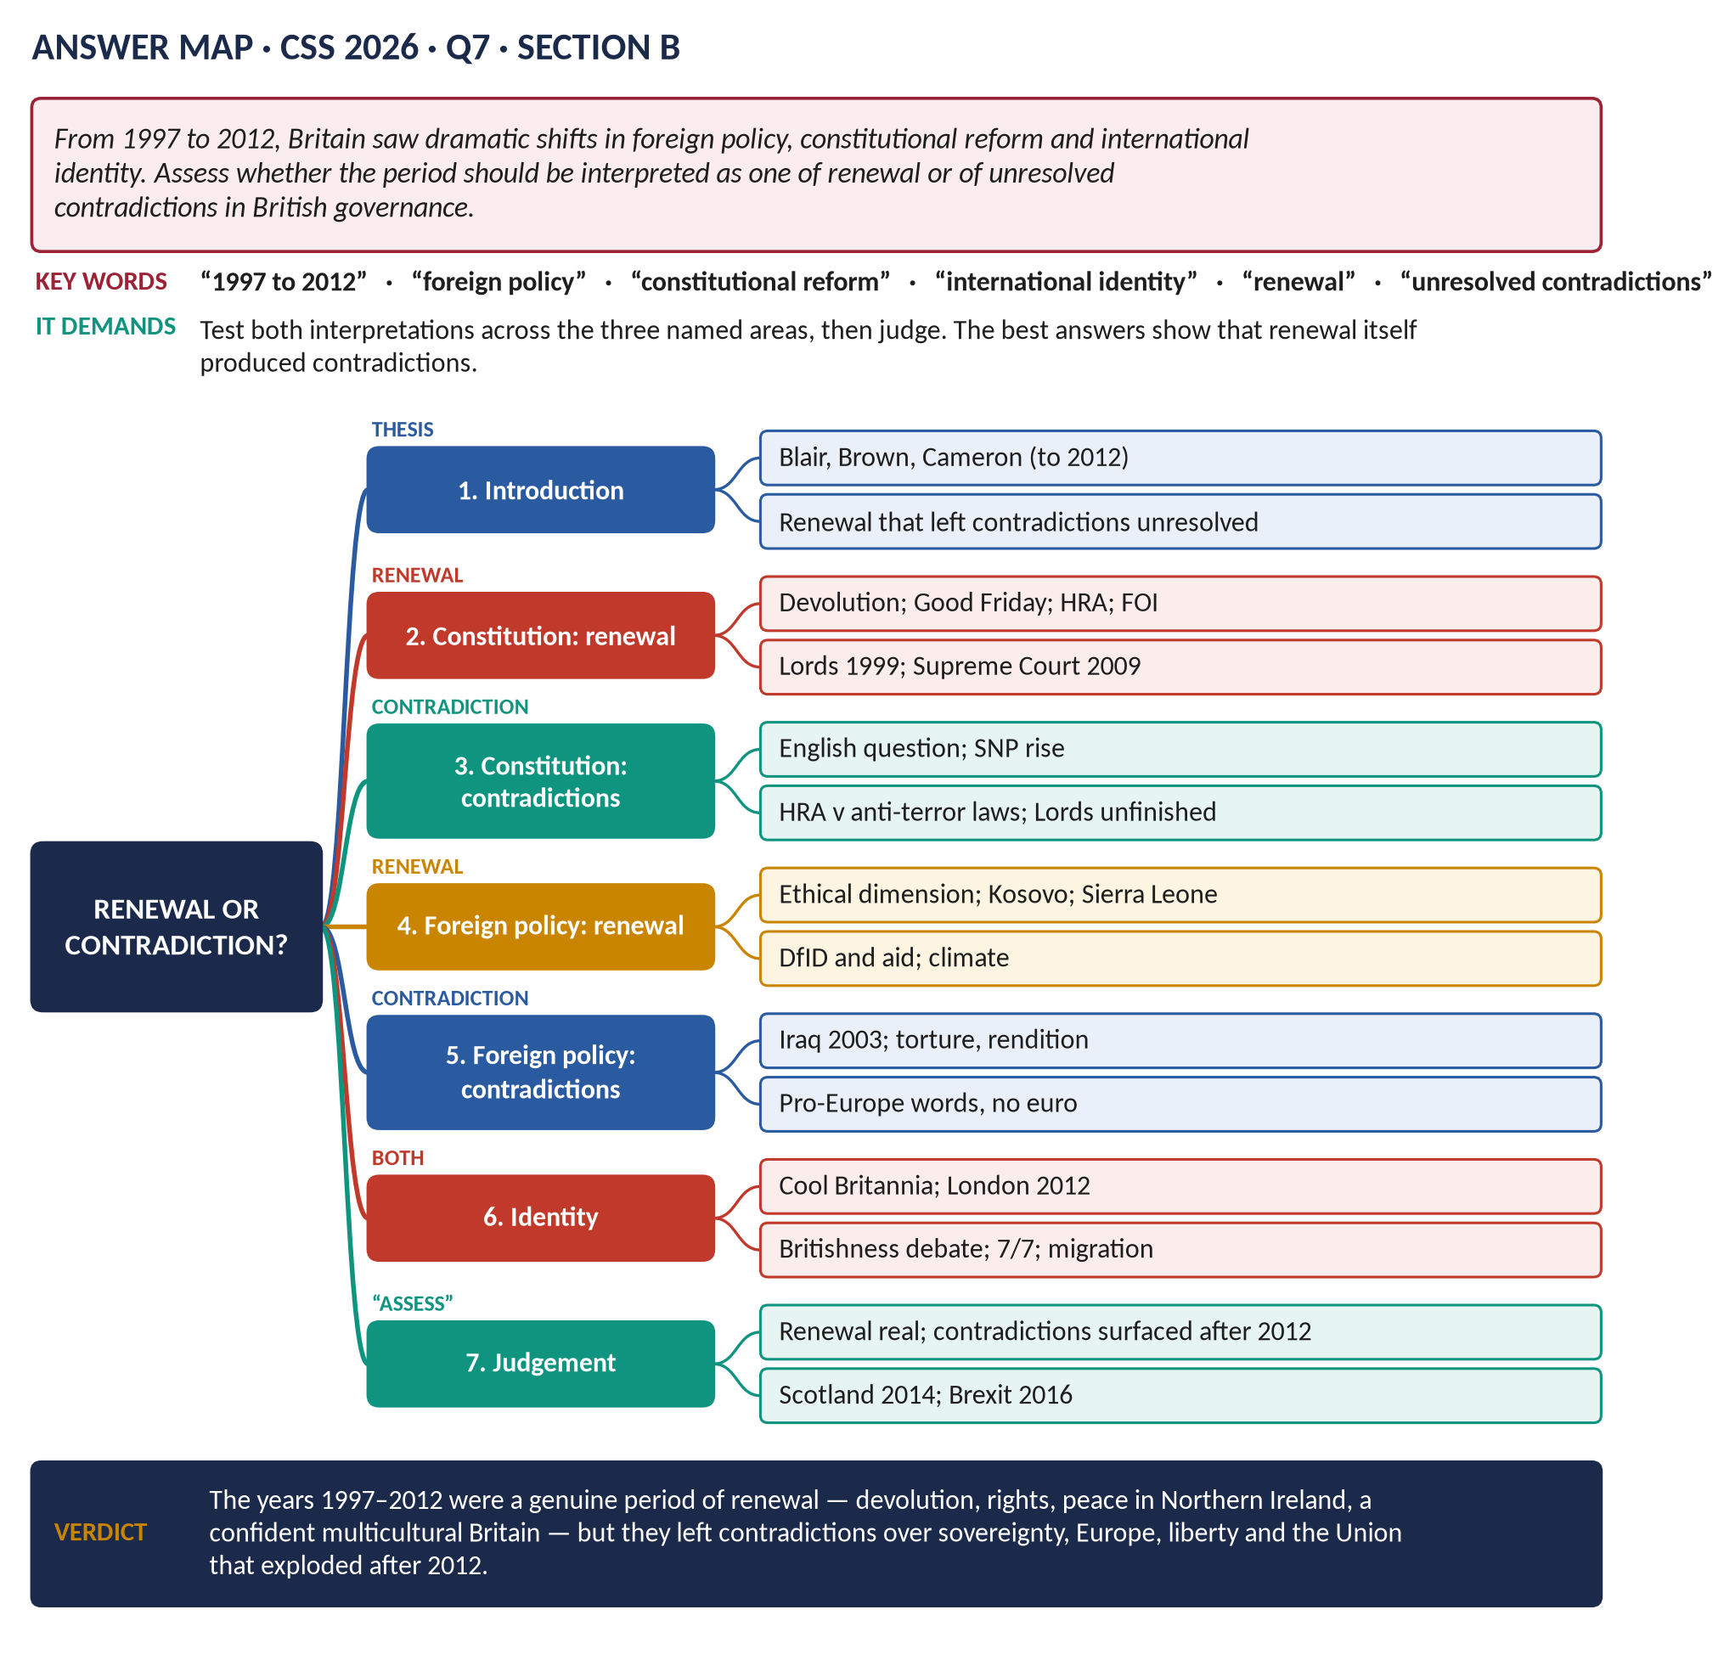
Figure 3 · The answer map for CSS 2026 · Q7 · Section B: every branch is one heading of the answer below.
DECODING THE QUESTION
"Assess whether" the period should be seen as renewal (a fresh start, modernisation) or as unresolved contradictions (tensions and inconsistencies left unsettled). The question names three areas: foreign policy, constitutional reform and international identity. Test both views in each area, then judge. The best answers show that renewal itself created the contradictions.

The model answer

Introduction
Between 1997 and 2012 Britain was governed by Tony Blair (1997–2007), Gordon Brown (2007–10) and, from 2010, David Cameron's coalition. These years saw a constitutional revolution, a new interventionist foreign policy and a confident, multicultural national image — symbolised by the London Olympics of 2012. This answer argues that the period was a genuine renewal, but one that left deep contradictions — over the Union, rights and security, Europe, and the legitimacy of war — which were papered over until 2012 and then broke open in the Scottish referendum (2014) and Brexit (2016).

Constitutional reform

(1) Renewal
- Devolution: the Scottish Parliament and Welsh Assembly (1999); the Mayor of London (2000).
- Peace: the Good Friday Agreement (1998) ended thirty years of conflict in Northern Ireland with power-sharing.
- Rights: the Human Rights Act (1998); the Freedom of Information Act (2000).
- Institutions: most hereditary peers removed (1999); the Supreme Court (2009); Bank of England independence (1997).
- Vernon Bogdanor called it "the new British constitution".

(2) Contradictions
1. The English question: Scotland had its own parliament, but England had none; Scottish MPs voted on English laws (the West Lothian question).
2. Devolution strengthened nationalism: the SNP won power in Scotland (2007) and a majority (2011), leading to the 2014 independence referendum — the opposite of what Labour intended.
3. Rights v security: the Human Rights Act clashed with anti-terror laws (Belmarsh detentions ruled unlawful, 2004; control orders).
4. Unfinished reform: the Lords remained unelected (the coalition's 2012 reform bill was abandoned); the AV referendum failed (2011).

Foreign policy

(3) Renewal
- An "ethical dimension" (Robin Cook, 1997).
- Humanitarian intervention that worked: Kosovo (1999) and Sierra Leone (2000).
- Development: DfID (1997), aid doubled, debt relief, Gleneagles (2005); climate leadership (the Climate Change Act, 2008).
- Europe: the Social Chapter, St Malo defence initiative.

(4) Contradictions
1. Iraq (2003): an "ethical" government joined a war on false WMD claims, without a new UN resolution — the Chilcot Report (2016) was damning.
2. Values and practice: complicity in rendition and torture contradicted human-rights rhetoric.
3. Europe: Blair wanted Britain "at the heart of Europe" but kept out of the euro and ratified the Lisbon Treaty without a referendum — feeding Euroscepticism.
4. The special relationship: the "bridge" between the USA and Europe broke over Iraq.
5. Libya (2011): intervention without a plan for the aftermath.

International identity

(5) Renewal
- "Cool Britannia": a modern, creative, multicultural image.
- Social liberalism: civil partnerships (2004), equality laws.
- London 2012: a celebration of a diverse, confident nation.

(6) Contradictions
- The Britishness debate: Gordon Brown's call for shared British values reflected uncertainty about national identity in a devolved, diverse country.
- 7/7 (2005): home-grown terrorism challenged multiculturalism.
- Immigration: large-scale migration after the EU's enlargement (2004) produced a backlash and the rise of UKIP.
- The economy: a boom built on the City and debt ended in the 2008 crash and austerity — undermining the image of a confident, prosperous Britain.

Judgement
Area | Renewal | Contradiction
Constitution | Devolution, peace, rights | English question; SNP; rights v security
Foreign policy | Kosovo, Sierra Leone, aid | Iraq; torture; Europe without the euro
Identity | Cool Britannia; London 2012 | Britishness; 7/7; immigration; the crash

VERDICT · Conclusion
The years 1997–2012 were a genuine period of renewal: Britain's constitution was transformed, peace came to Northern Ireland, public services and social attitudes were modernised, and the country projected a confident, diverse identity to the world. But the renewal was incomplete and often inconsistent: devolution raised questions about England and the Union, an "ethical" foreign policy led to Iraq, a pro-European government stayed outside the euro, and a debt-fuelled boom ended in crisis. These unresolved contradictions exploded after 2012 — in the Scottish referendum of 2014 and the Brexit vote of 2016 — so the period is best seen as renewal that left its hardest questions unanswered.

WHY THIS ANSWER SCORES · Why this answer scores
It tests both interpretations in each of the three named areas · specific evidence (Good Friday, HRA, Belmarsh, Kosovo, Chilcot, Lisbon, 7/7, London 2012) · the link between renewal and later crises (2014, 2016) · a summary table and a clear judgement.

Answer 3 · Blair's War on Terror and US–British Relations
THE QUESTION · CSS 2021 · Q8 · Section B · 20 marks
What were the salient features of Tony Blair's policy on the War on Terror? How did his policy affect US-Britain relations?

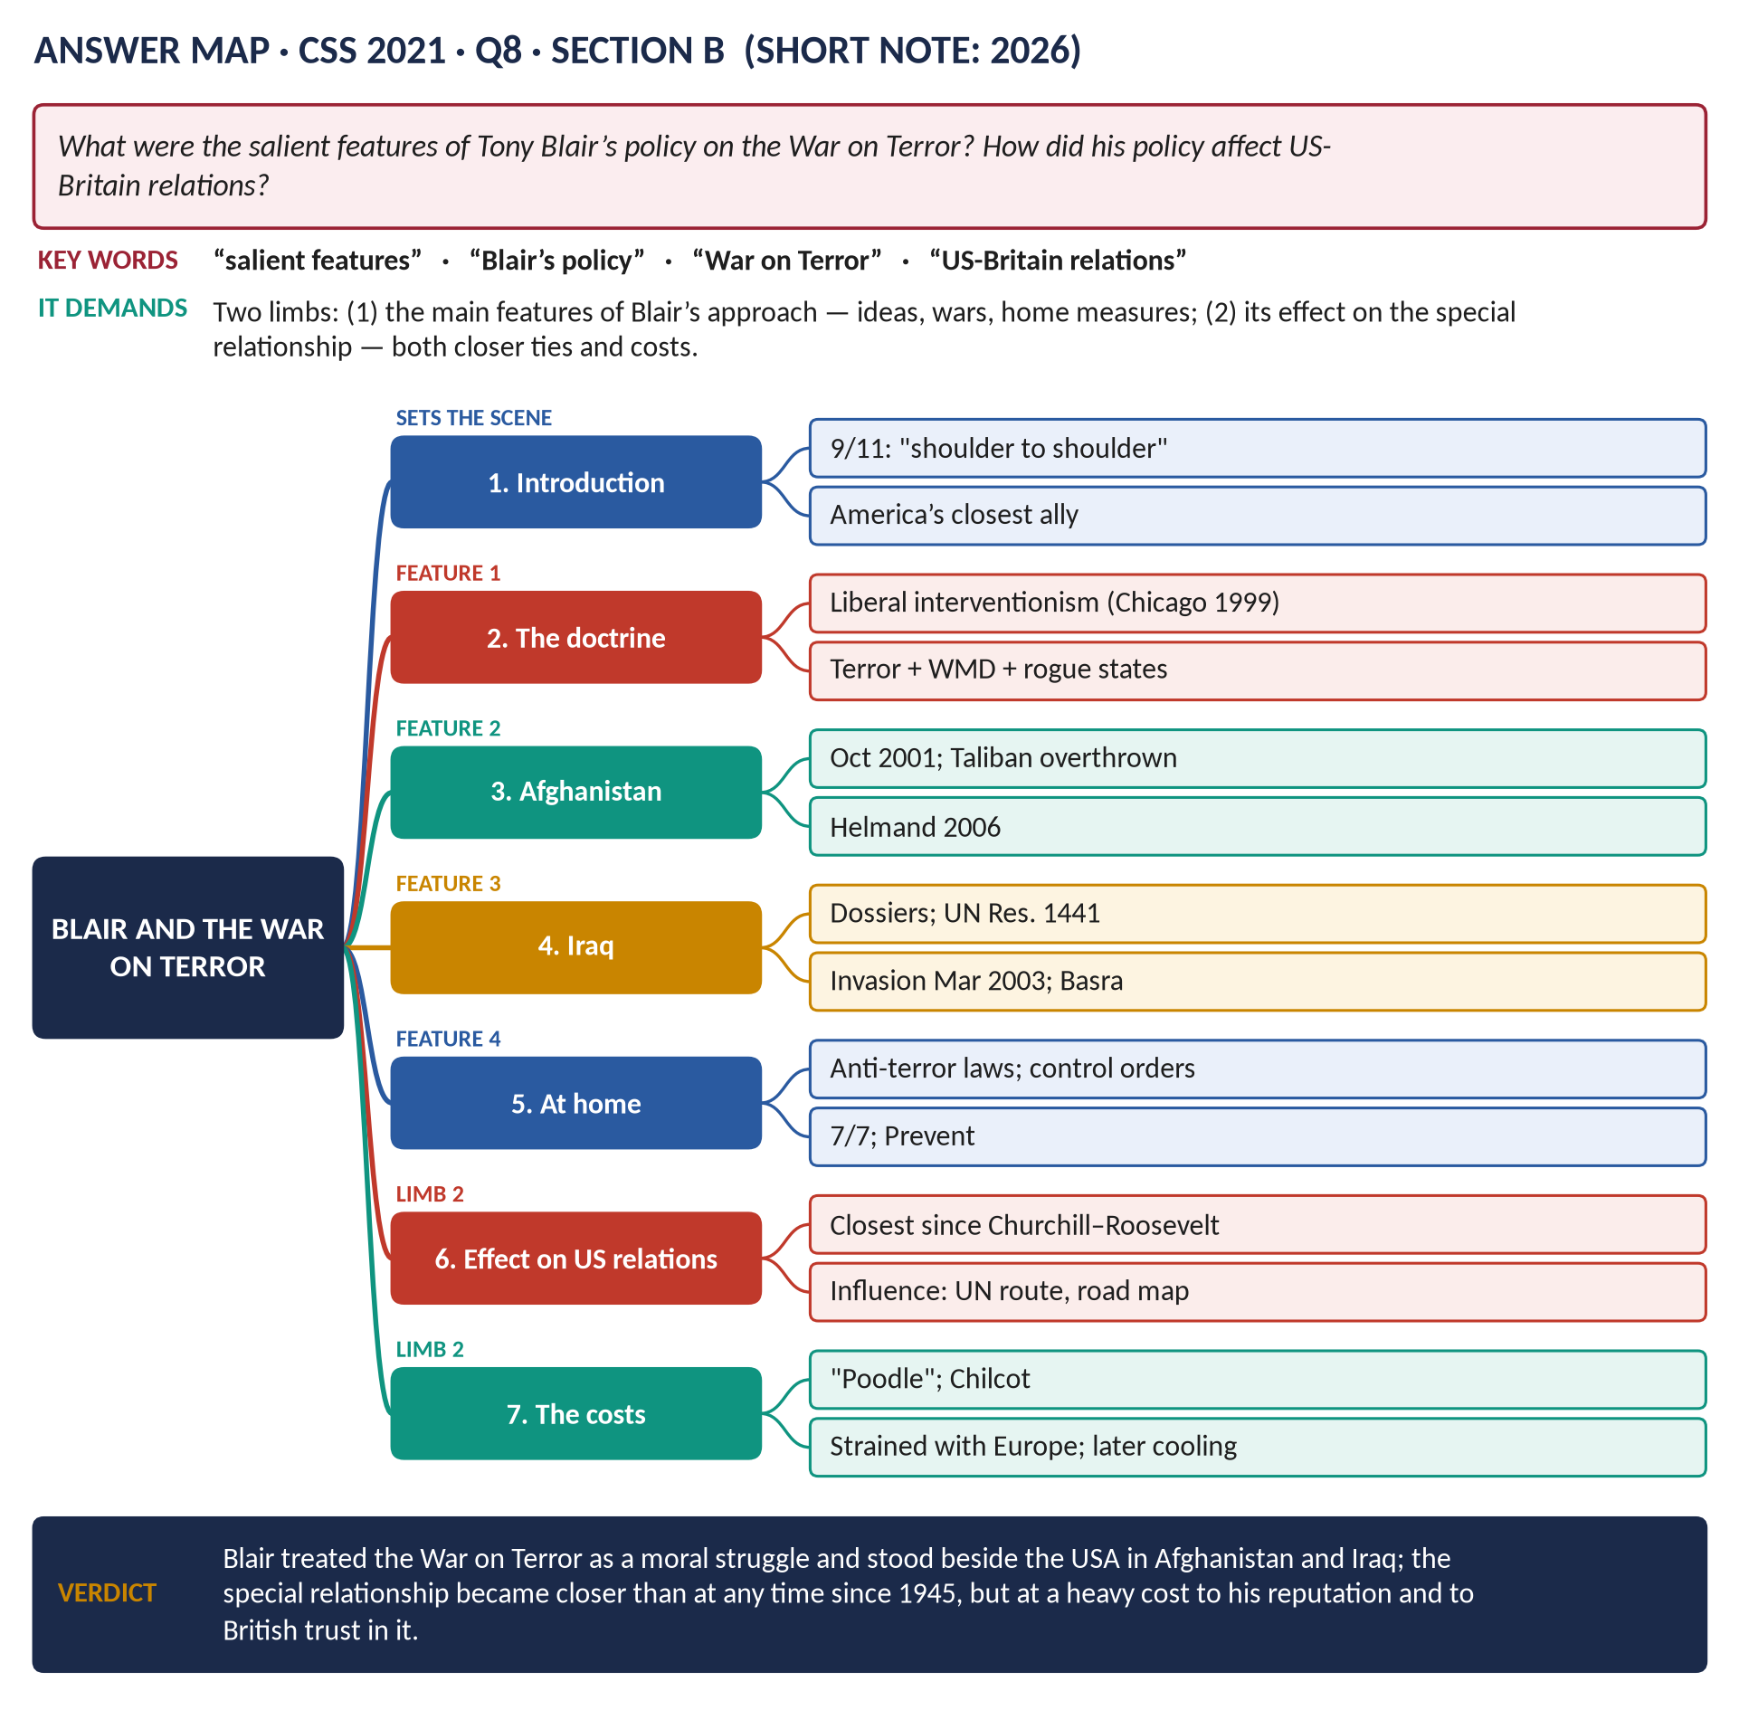
Figure 4 · The answer map for CSS 2021 · Q8 · Section B: every branch is one heading of the answer below.
DECODING THE QUESTION
Two limbs. (1) "What were the salient features of Tony Blair's policy on the War on Terror?" — the main characteristics: his ideas (why he fought), the wars (Afghanistan, Iraq), the home measures, and his diplomacy. (2) "How did his policy affect US-Britain relations?" — both the strengthening of the relationship and its costs.

The model answer

Introduction
After the terrorist attacks of 11 September 2001, Tony Blair became the most important ally of President George W. Bush in the "War on Terror". His policy had clear features: a moral view of the struggle, military intervention in Afghanistan and Iraq, tough security laws at home, and an effort to influence America from the inside. It made the US–British relationship closer than at any time since the Second World War — but it left Blair branded "Bush's poodle", damaged Britain's relations with Europe, and after Iraq made the British public and Parliament wary of following the USA into war.
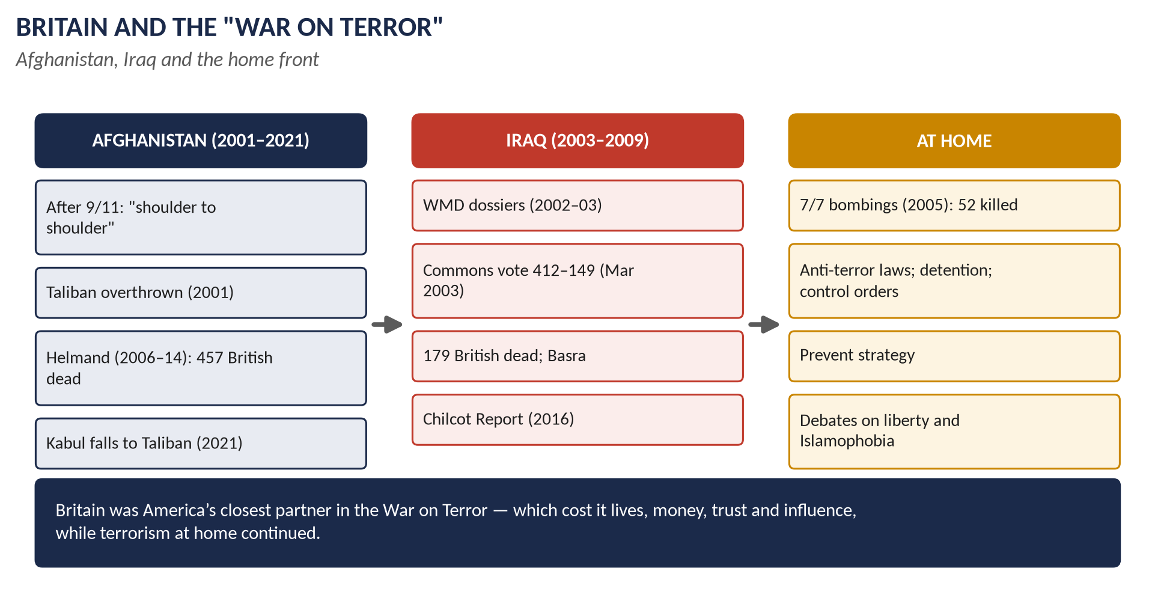
Figure 5 · Britain and the War on Terror.

Limb 1 · The salient features of Blair's policy

(1) Solidarity with America
On 9/11 Blair declared that Britain would stand "shoulder to shoulder" with the USA. He flew to Washington, sat in the gallery for Bush's speech to Congress, and travelled the world building support for the campaign.

(2) A moral, interventionist doctrine
- Blair saw terrorism, rogue states and weapons of mass destruction as a single new threat that justified pre-emptive action.
- It built on his Chicago speech (1999): the "doctrine of the international community" — intervening to stop evil (Kosovo, Sierra Leone).
- He spoke of a struggle between values — freedom and democracy against extremism.

(3) Afghanistan (2001–)
- British forces joined the US attack (October 2001) that overthrew the Taliban, who sheltered al-Qaeda.
- Britain led the first ISAF force in Kabul and from 2006 took over Helmand province; 457 British service personnel died by 2014.

(4) Iraq (2003)
- Blair argued that Saddam Hussein's WMD threatened the world: the September Dossier (2002) ("45 minutes") and the "dodgy dossier" (2003).
- He persuaded Bush to seek UN Resolution 1441 (November 2002), but failed to obtain a second resolution.
- He won a Commons vote (18 March 2003; 412 to 149, with 139 Labour rebels); Robin Cook resigned.
- About 46,000 British troops joined the invasion (20 March 2003); Britain controlled Basra until 2009; 179 British deaths. No WMD were found.

(5) Security measures at home
- The Anti-terrorism, Crime and Security Act (2001): detention without trial of foreign suspects (Belmarsh).
- Control orders (2005); the attempt at 90-day detention (defeated 2005).
- After 7/7 (2005), new laws against glorifying terrorism; the Prevent strategy.

(6) Diplomacy and "hearts and minds"
- Blair pressed Bush to launch the Middle East "road map" (2003) for Israel and Palestine.
- He tried to act as a bridge between the USA and Europe.

Limb 2 · The effect on US–British relations

(7) A closer relationship
1. Personal closeness: Blair and Bush met and spoke constantly — the closest partnership since Churchill and Roosevelt.
2. Military and intelligence integration: British forces fought beside American forces for a decade; intelligence sharing deepened.
3. American gratitude: Blair was awarded the Congressional Gold Medal (2003) and hugely admired in the USA.

(8) British influence — real but limited
- Blair persuaded Bush to go to the UN first (1441) and to issue the Middle East road map.
- But he failed to secure a second UN resolution, a plan for post-war Iraq, or real movement on Palestine. The Chilcot Report (2016) found he had overestimated his ability to influence US decisions; his note of July 2002, "I will be with you, whatever", suggested unconditional support.

(9) The costs for Britain
1. "Poodle": Blair was widely seen as following Bush uncritically.
2. Europe split: France and Germany opposed the war; the "bridge" collapsed.
3. Public trust: the WMD failure and the death of Dr David Kelly (2003) damaged trust in government and in the "special relationship".
4. Terrorism at home: the 7/7 bombers cited Iraq and Afghanistan.

(10) Long-term effects
- Brown was more reserved with Bush; Obama spoke of an "essential relationship".
- The "Iraq syndrome": in August 2013 the Commons refused to join US strikes on Syria — a sign that Britain would no longer automatically follow America.
VERDICT · Conclusion
Blair's War on Terror policy was marked by total solidarity with America, a moral belief in intervention, wars in Afghanistan and Iraq, tough security laws, and efforts to influence the USA from within. It made the Anglo-American relationship closer than at any time since 1945 and gave Britain a voice in Washington. But Iraq — fought on false claims and without a plan — made Blair look like America's poodle, split Britain from Europe, and left a lasting reluctance in Britain to follow the USA into war.

WHY THIS ANSWER SCORES · Why this answer scores
Limb 1 gives six salient features (ideas, two wars, home laws, diplomacy) with dates and figures · Limb 2 covers the closer relationship, the limits of influence (Chilcot), the costs and the long-term effects · a balanced verdict.

Answer 4 · "Smoke Them Out of Their Holes": A Balanced Critique of the War on Terror
THE QUESTION · CSS 2023 · Q7 · Section B · 20 marks
'We will find those who did it, we will smoke them out of their holes, we will get them running and we will bring them to justice.' In the context of this remark, present a balanced critique of the War on Terror with special emphasis on the role of Great Britain.

Figure 6 · The answer map for CSS 2023 · Q7 · Section B: every branch is one heading of the answer below.
DECODING THE QUESTION
The quotation is President George W. Bush, speaking days after 9/11 (September 2001). "In the context of this remark, present a balanced critique of the War on Terror with special emphasis on the role of Great Britain" — explain what the remark promised (to hunt down and bring to justice the attackers); then give a balanced critique — achievements and failures — with Britain's role at the centre.

The model answer

Introduction
Days after al-Qaeda's attacks of 11 September 2001 killed about 3,000 people, President George W. Bush promised: "We will find those who did it, we will smoke them out of their holes, we will get them running and we will bring them to justice." The words promised a focused manhunt for the terrorists. The "War on Terror" that followed became something much larger — two long wars, in Afghanistan and Iraq, and a global security campaign. Britain, under Tony Blair, was America's closest partner in all of it. A balanced critique shows that the campaign did bring many terrorists to justice and prevented further attacks, but that its wars — especially Iraq — went far beyond the original aim, caused enormous suffering, and helped create new terrorism.
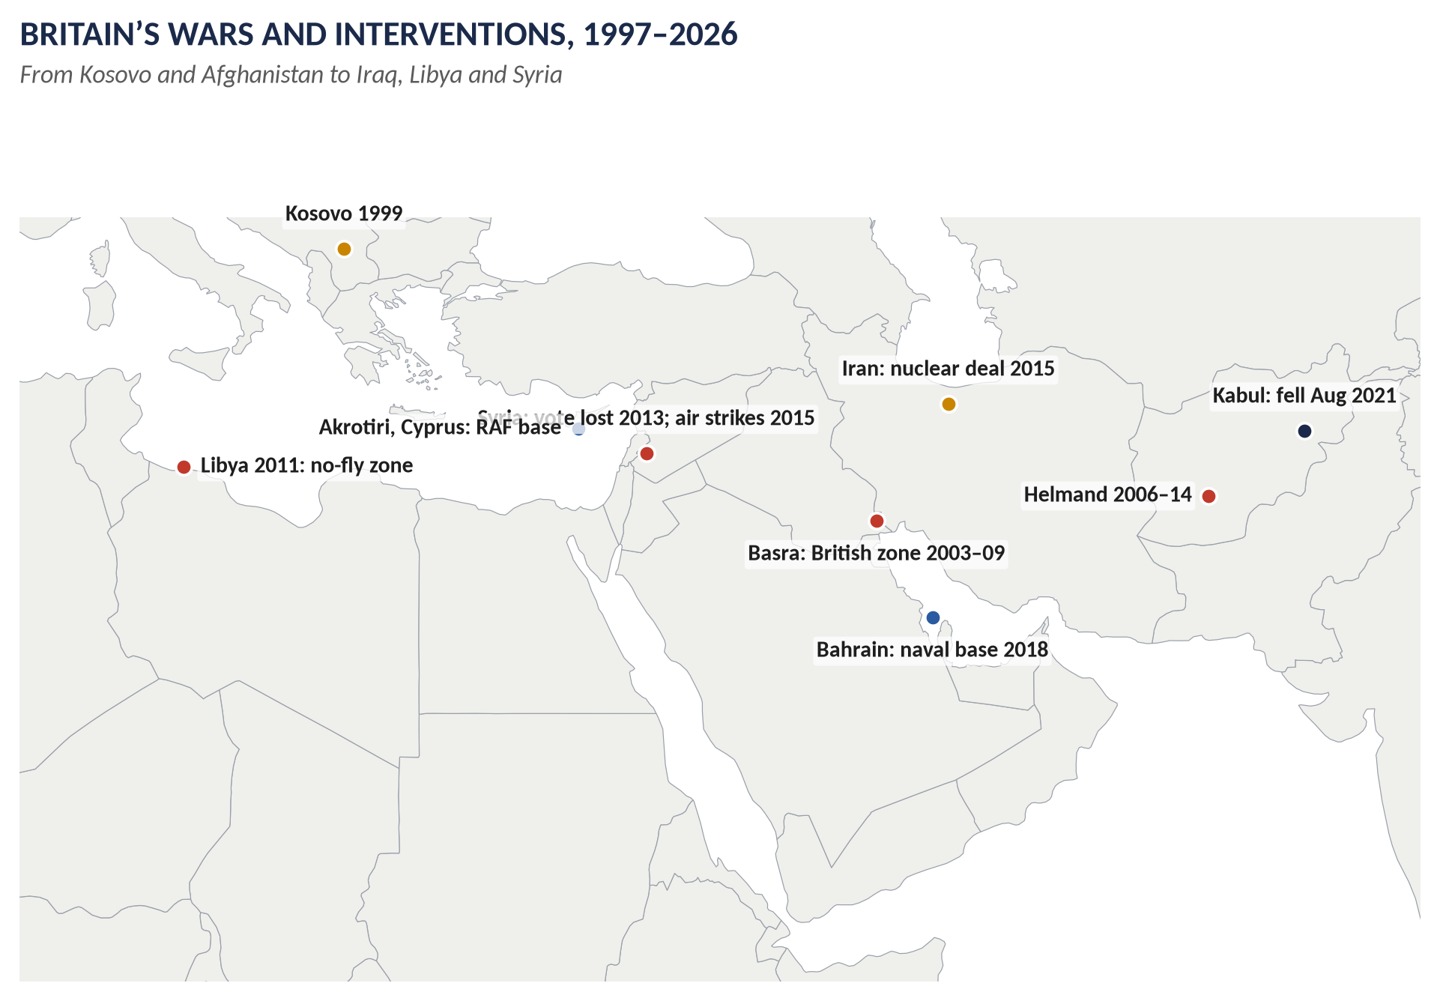
Figure 7 · Britain's wars and interventions.

The remark and the aims

(1) What Bush promised
A war of justice against those responsible for 9/11 — al-Qaeda and Osama bin Laden — and those who sheltered them (the Taliban). It was broadened within months into a war on all terrorist groups and "rogue states" with weapons of mass destruction (the "axis of evil", January 2002).

(2) Britain's role
Blair pledged to stand "shoulder to shoulder" with America; Britain joined the attack on Afghanistan (October 2001), the invasion of Iraq (March 2003), and a global campaign of intelligence and security cooperation.

Achievements

(3) "Smoking them out" — partly achieved
- Afghanistan: the Taliban regime was overthrown in weeks (2001); al-Qaeda lost its safe base.
- Bin Laden was found and killed by US forces in Pakistan (May 2011); many al-Qaeda leaders were killed or captured.
- Plots foiled: British and US intelligence stopped many attacks (for example the 2006 plot to blow up transatlantic airliners).
- No repeat of 9/11 on its scale.
- Afghan progress (2001–21): elections, girls' education, a free press — for twenty years.

(4) Britain's contribution
Special forces, intelligence (GCHQ, MI6), Helmand's reconstruction teams, and diplomatic leadership in building the coalition.

Failures and costs

(5) Iraq — the central failure
- Iraq had no link to 9/11 and no WMD — the grounds for war were false.
- Britain's dossiers exaggerated the intelligence; no second UN resolution was obtained; many lawyers regard the war as illegal.
- The Chilcot Report (2016): war before peaceful options were exhausted; "wholly inadequate" planning.
- Human cost: 179 British dead; Iraqi deaths in the hundreds of thousands; millions displaced; sectarian civil war.
- Iraq created new terrorism: al-Qaeda in Iraq, and later ISIS (2014).

(6) Afghanistan — a lost war
- British forces in Helmand (2006–14): 457 British deaths; limited progress against the Taliban and opium.
- August 2021: the Taliban retook Kabul within days of the US withdrawal; twenty years of effort collapsed.

(7) Justice and values
- Guantánamo, rendition and torture — British intelligence was complicit in some cases (the 2018 Intelligence and Security Committee reports).
- Detention without trial (Belmarsh, 2001–04) and control orders in Britain.
- Prevent was accused of stigmatising Muslims; Islamophobia rose.
- These undermined the very values the War on Terror claimed to defend.

(8) Terrorism at home
- 7/7 (2005): 52 killed by British-born bombers who cited Iraq and Afghanistan.
- Later attacks (2017: Westminster, Manchester Arena, London Bridge).

(9) Political costs for Britain
- Blair's reputation destroyed ("Bush's poodle"); public trust in government fell.
- Britain's standing in the Muslim world and in Europe damaged.
- The "Iraq syndrome": Parliament refused Syria strikes (2013).
Achievements | Failures
Taliban overthrown (2001); bin Laden killed (2011) | Iraq on false grounds; illegal?; Chilcot
Many plots foiled; no new 9/11 | Hundreds of thousands dead; ISIS
Twenty years of Afghan progress | Taliban back (2021)
International intelligence cooperation | Torture, rendition, detention without trial
 | 7/7; terrorism at home; lost trust

VERDICT · Conclusion
Measured against Bush's promise, the War on Terror partly succeeded: al-Qaeda lost its Afghan base, bin Laden was killed and many plots were stopped. But the campaign went far beyond bringing the 9/11 attackers to justice. Britain's role was central — Blair was America's chief partner — and Britain shared the responsibility for its greatest failure: an invasion of Iraq on false grounds that killed hundreds of thousands, helped create ISIS and fuelled terrorism at home, while the war in Afghanistan ended in the Taliban's return. On balance, the War on Terror did more to spread the violence it aimed to end than to defeat it.

WHY THIS ANSWER SCORES · Why this answer scores
It explains the remark and shows how the war went beyond it · the critique is genuinely balanced — a full section of achievements and of failures · Britain's role is at the centre throughout (Blair, Helmand, Basra, dossiers, Chilcot, 7/7) · a summary table and a reasoned verdict.

Answer 5 · How the Financial Crisis Plunged Britain into Recession, and How It Responded
THE QUESTION · CSS 2023 · Q8 · Section B · 20 marks
How did the global financial crisis plunge Britain into recession in the 21st century and how did it respond?

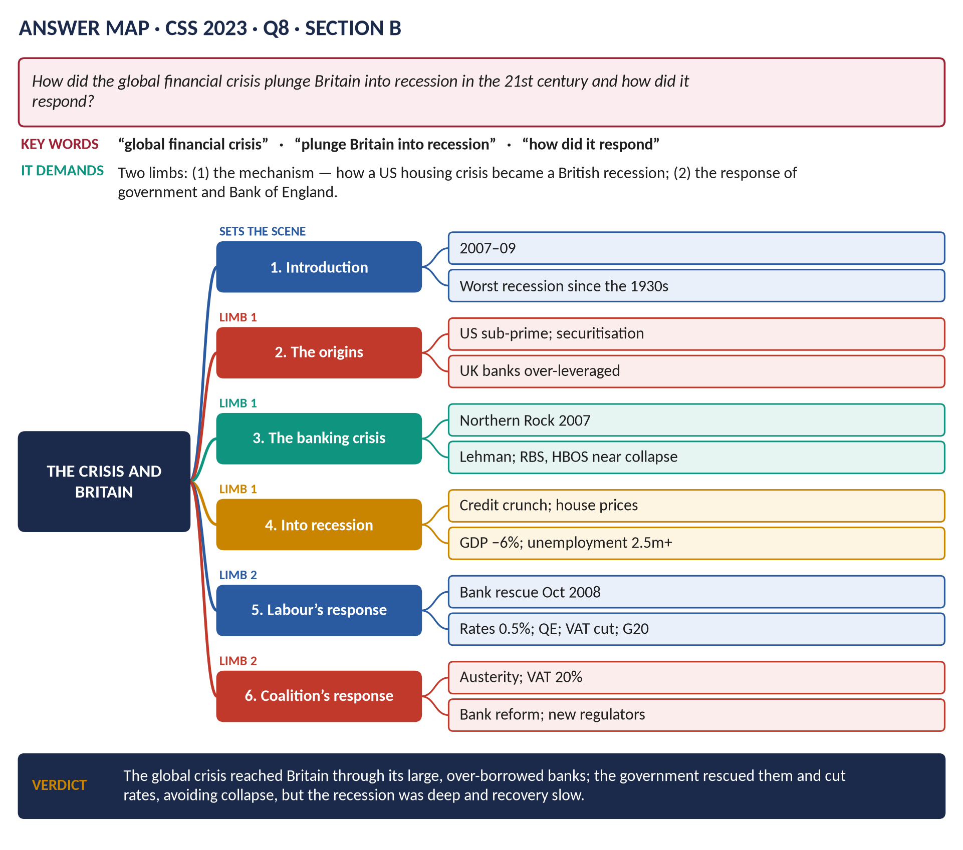
Figure 8 · The answer map for CSS 2023 · Q8 · Section B: every branch is one heading of the answer below.
DECODING THE QUESTION
Two limbs. (1) "How did the global financial crisis plunge Britain into recession?" — explain the chain: from American mortgages to British banks, to the credit crunch, to falling output and jobs. (2) "… and how did it respond?" — the actions of the government (Labour, 2007–10, and briefly the coalition from 2010) and the Bank of England.

The model answer

Introduction
The global financial crisis of 2007–09 began in the American housing market, but it hit Britain with special force because Britain's economy depended so heavily on its huge, over-borrowed banks. As banks failed or nearly failed, lending dried up, confidence collapsed and Britain suffered its deepest recession since the Second World War, with output falling by about 6 per cent. The Labour government of Gordon Brown and Alistair Darling responded boldly — rescuing the banks, cutting interest rates to almost zero and stimulating the economy — and led a coordinated international response; from 2010 the coalition turned to austerity to cut the huge deficit.
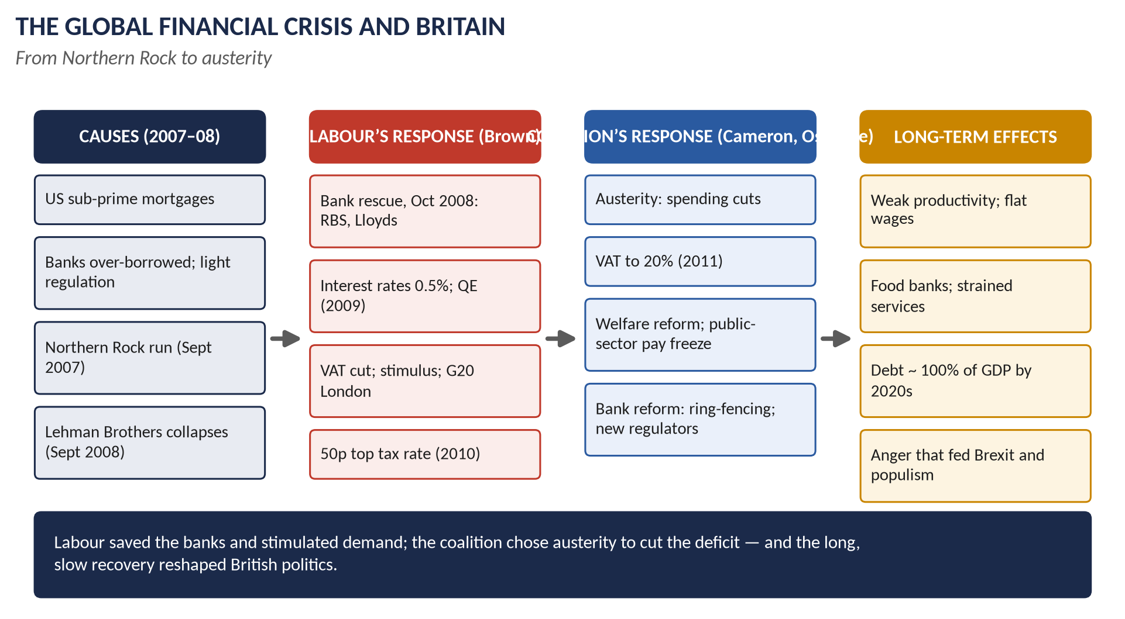
Figure 9 · The crisis and Britain.

Limb 1 · How the crisis caused recession

(1) The American origins
- US banks lent to "sub-prime" borrowers who could not repay; these mortgages were bundled into complex securities and sold to banks around the world.
- When US house prices fell (2006–07), the securities lost value; no one knew which banks held the bad debts.

(2) Britain's vulnerability
- British banks had grown to over four times the size of the economy; RBS was briefly the world's largest bank.
- They relied on short-term borrowing from the money markets rather than savers' deposits.
- Regulation by the Financial Services Authority was "light-touch".
- Households had borrowed heavily; house prices had soared.

(3) The banking crisis
- Northern Rock (September 2007): unable to borrow on the markets, it asked the Bank of England for help; savers queued to withdraw their money — the first bank run in Britain for about 150 years. It was nationalised (February 2008).
- Lehman Brothers collapsed (15 September 2008); markets froze. HBOS was rescued by Lloyds; Bradford & Bingley was nationalised; RBS was hours from collapse (October 2008).

(4) From banking crisis to recession
1. The credit crunch: banks stopped lending to businesses and households.
2. Falling confidence: businesses cut investment and jobs; consumers cut spending.
3. House prices fell, making people feel poorer.
4. World trade collapsed, hitting exports.
5. Result: GDP fell by about 6 per cent (2008–09); unemployment rose to about 2.5 million; government borrowing reached about 10 per cent of GDP.

Limb 2 · How Britain responded

(5) The bank rescue (October 2008)
On 8 October 2008 Brown and Darling announced a package of about £500 billion in guarantees, loans and new capital. The state took large stakes in RBS (eventually about 84 per cent) and Lloyds (about 43 per cent). Other countries copied the British model.

(6) Monetary policy
- The Bank of England cut Bank Rate from 5 per cent to 0.5 per cent (March 2009) — the lowest in its history.
- Quantitative easing (from March 2009): the Bank created money to buy government bonds — £375 billion by 2012.

(7) Fiscal stimulus
- VAT cut from 17.5 to 15 per cent (December 2008 – January 2010).
- Public spending maintained; a car scrappage scheme; help for homeowners and the unemployed.
- A new 50p top rate of income tax (2010).

(8) International leadership
Brown hosted the G20 summit in London (April 2009), which agreed about $1 trillion for the IMF and world economy — widely credited with preventing a second Great Depression.

(9) The coalition's response (from 2010)
- Austerity: George Osborne set out to eliminate the deficit through spending cuts (about 80 per cent) and tax rises (VAT to 20 per cent, 2011).
- Banking reform: the Vickers report (2011) — ring-fencing of retail banking; the FSA replaced by the Prudential Regulation Authority and Financial Conduct Authority (2013).

(10) Results
- The banking system was saved; the recession ended in 2009; but the recovery was the slowest for a century, with stagnant wages and weak productivity.
VERDICT · Conclusion
The global financial crisis plunged Britain into recession because its enormous, over-borrowed banks were exposed to American bad debts: when they failed, credit dried up, confidence collapsed and output fell by about 6 per cent. Britain's response — the bank rescue, near-zero interest rates, quantitative easing and a fiscal stimulus under Labour, followed by austerity and banking reform under the coalition — prevented a financial collapse, but could not prevent a long and painful recovery.

WHY THIS ANSWER SCORES · Why this answer scores
Limb 1 shows the chain of causation step by step (US mortgages → British banks → credit crunch → recession) · Limb 2 covers government, Bank of England and international responses with figures and dates, and the coalition's turn to austerity · a clear verdict.

Answer 6 · The Financial Crisis: Impact, Two Responses and Long-Term Effects
THE QUESTION · CSS 2025 · Q7 · Section B · 20 marks
How did the global financial crisis of 2008 impact British politics and society? How did the responses of the Labour and Conservative governments differ, and what were their long-term effects?

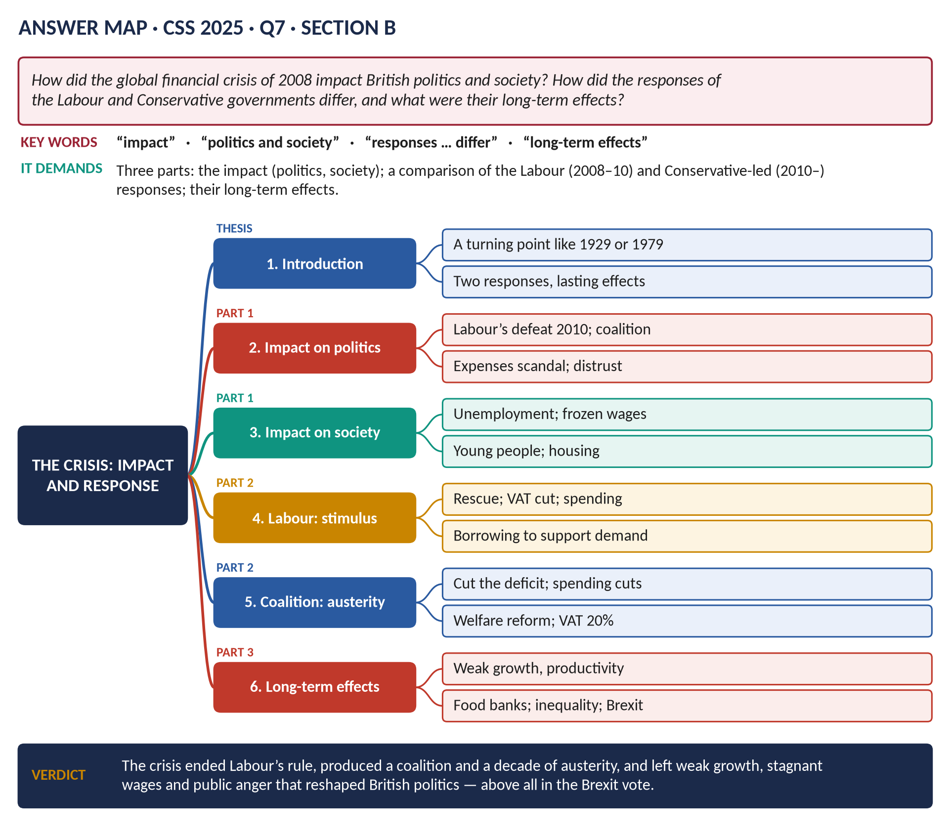
Figure 10 · The answer map for CSS 2025 · Q7 · Section B: every branch is one heading of the answer below.
DECODING THE QUESTION
Three parts. (1) "How did the global financial crisis of 2008 impact British politics and society?" (2) "How did the responses of the Labour and Conservative governments differ?" — Labour (Brown, 2008–10) v the Conservative-led coalition and Conservative governments (from 2010). (3) "… and what were their long-term effects?" — the lasting consequences of both responses.

The model answer

Introduction
The financial crisis of 2008 was a turning point in modern British history, comparable to 1929 or 1979. It ended the long boom of the New Labour years, brought down the Labour government, and produced the first coalition since 1945. Labour responded with Keynesian stimulus — rescuing the banks and supporting demand; the Conservative-led coalition chose austerity — cutting spending to reduce the deficit. The long-term effects — weak growth, stagnant wages, strained public services and deep public anger — reshaped British politics, and helped lead to Brexit.

Part 1 · The impact on politics and society

(1) Politics
1. The fall of Labour: the crisis destroyed Labour's claim to economic competence ("no return to boom and bust"); at the 2010 election Labour lost 91 seats.
2. A hung parliament and coalition: the Conservatives and Liberal Democrats formed the first peacetime coalition since the 1930s.
3. Distrust of elites: the MPs' expenses scandal (2009) and anger at bankers' bonuses deepened contempt for politicians and the City.
4. Protest: the student protests over tuition fees (2010); Occupy London (2011); the August 2011 riots.
5. New politics: the rise of UKIP, the SNP and, in Labour, Jeremy Corbyn (2015) — all feeding on anti-establishment anger.

(2) Society
1. Unemployment rose to about 2.5–2.7 million; youth unemployment passed 1 million (2011).
2. Wages: real wages fell and did not return to their 2008 level for over a decade — the longest squeeze since the Napoleonic Wars.
3. Housing: young people were priced out; home ownership among the young fell.
4. Poverty: food-bank use soared (the Trussell Trust: from about 26,000 people in 2008–09 to over 1 million by 2014–15).
5. Inequality between regions and generations widened.

Part 2 · How the two responses differed
Figure 11 · Two responses to the crisis.

(3) Labour's response (2008–2010): stimulus
- Philosophy: Keynesian — in a slump, government should borrow and spend to support demand.
- The bank rescue (October 2008): about £500 billion; part-nationalisation of RBS and Lloyds.
- Stimulus: VAT cut to 15 per cent; spending maintained; job schemes; car scrappage.
- Monetary support: Bank Rate at 0.5 per cent; quantitative easing (from 2009).
- Taxes on the rich: a 50p income-tax rate; a bonus tax on bankers.
- International: the G20 London summit (2009).

(4) The Conservative-led response (2010–2016): austerity
- Philosophy: fiscal consolidation — the deficit (about 10 per cent of GDP) threatened confidence; the state must shrink. "We're all in this together" (Osborne).
- Spending cuts: about a fifth of departmental budgets; local government cut by about 40 per cent; public-sector pay frozen.
- Welfare reform: benefit freezes; the benefit cap; Universal Credit.
- Taxes: VAT raised to 20 per cent (2011); the top rate cut to 45p (2013); the tax-free allowance raised.
- Bank reform: ring-fencing; new regulators (PRA and FCA, 2013).
- Monetary policy continued: near-zero rates and more QE.
 | Labour (2008–10) | Conservative-led (2010–16)
Aim | Protect jobs and output | Cut the deficit
Spending | Maintained | Cut sharply
Tax | VAT cut; 50p rate | VAT 20%; top rate 45p
Banks | Rescue | Reform
Welfare | Protected | Cut and restructured

Part 3 · The long-term effects

(5) Of Labour's response
- The rescue prevented a banking collapse and a depression; the taxpayer eventually sold most bank shares (Lloyds fully returned to private hands in 2017; NatWest/RBS in 2025), though at a loss on RBS.
- QE and low rates kept the economy afloat but inflated asset prices — benefiting homeowners and the wealthy more than the young and poor.
- Debt rose sharply.

(6) Of austerity
1. Slow recovery: growth and productivity well below the pre-2008 trend — the "productivity puzzle".
2. Weaker public services: the NHS, social care, councils, prisons and courts under strain.
3. Poverty and inequality: food banks; child poverty rose again after 2012.
4. The deficit was cut, but debt stayed high (near 100 per cent of GDP after Covid).
5. Brexit: research (e.g. Thiemo Fetzer, 2019) found that austerity cuts increased the Leave vote, especially in poorer areas.

(7) For British politics
- The end of the post-1997 consensus; the rise of populism on left and right.
- A lasting debate between austerity and investment — revived after Truss's mini-budget (2022) and in the Labour governments of Starmer (2024–26) and Burnham (from 2026).
VERDICT · Conclusion
The 2008 crisis ended Labour's rule, created a coalition, deepened distrust of politicians and bankers, and left millions poorer. Labour responded with a Keynesian rescue and stimulus that prevented collapse; the Conservative-led coalition chose austerity to cut the deficit. Together these responses saved the banks but produced a decade of weak growth, stagnant wages and strained services — the soil in which anti-establishment politics, and the vote for Brexit, grew.

WHY THIS ANSWER SCORES · Why this answer scores
All three parts addressed separately · the impact is split into politics and society · the two responses are compared point by point in a table · the long-term effects of each response are traced to the present (Brexit, populism, debt) · a strong conclusion.

Answer 7 · David Cameron's Foreign Policy, with Special Reference to the Middle East
THE QUESTION · CSS 2016 · Q7 · Section B · 20 marks
Discuss the main features of the foreign policy of David Cameron with special reference to the Middle East.

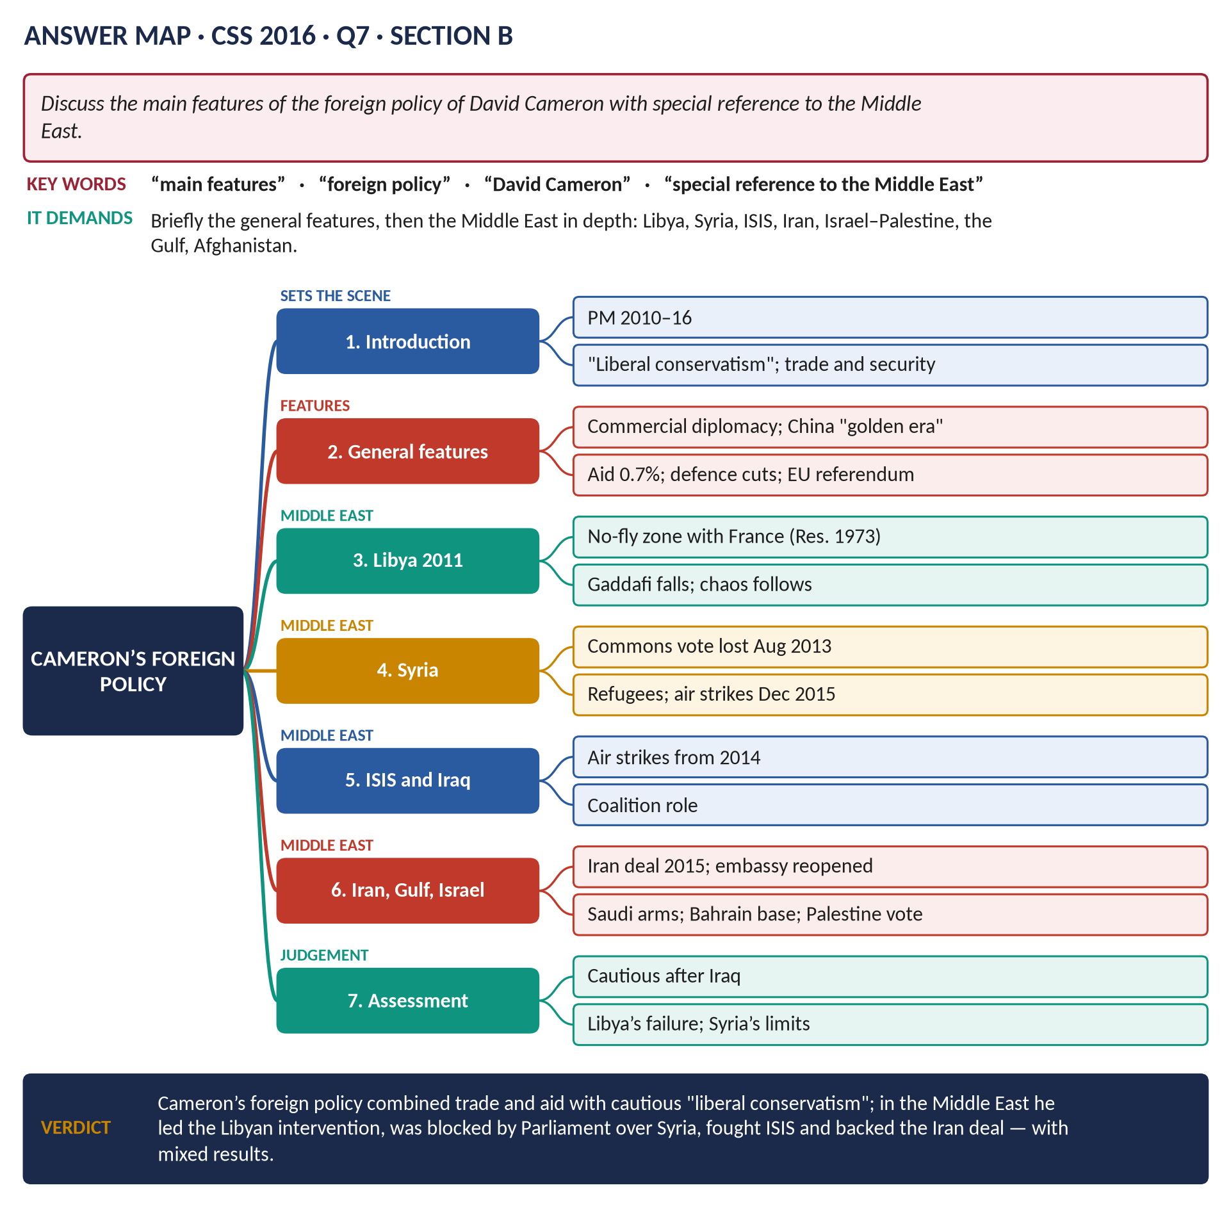
Figure 12 · The answer map for CSS 2016 · Q7 · Section B: every branch is one heading of the answer below.
DECODING THE QUESTION
"Discuss the main features of the foreign policy of David Cameron" — his general approach and priorities (2010–16). "With special reference to the Middle East" — most of the answer must be on the region: the Arab Spring, Libya, Syria, ISIS, Iran, the Gulf, Israel–Palestine and Afghanistan. End with an assessment.

The model answer

Introduction
David Cameron was Prime Minister from 2010 to 2016, first in coalition with the Liberal Democrats and then with a Conservative majority. His foreign policy was shaped by the lessons of Iraq and by the financial crisis: he called himself a "liberal conservative" — committed to freedom and democracy, but "not a naive neo-conservative". Its main features were commercial diplomacy, a large aid budget, cuts in defence, a cautious approach to military intervention, and, at the end, the EU referendum. In the Middle East he led the intervention in Libya (2011), was defeated by Parliament over Syria (2013), joined the campaign against ISIS, supported the Iran nuclear deal and kept close ties with the Gulf — with very mixed results.

General features

(1) "Liberal conservatism"
Support for democracy and human rights, but realism about what force could achieve: "we cannot drop democracy from 40,000 feet".

(2) Commercial diplomacy
Foreign policy was to serve trade and growth: many trade missions; the "golden era" with China (Xi Jinping's state visit, October 2015); arms and trade deals with the Gulf and India.

(3) Aid and soft power
Aid at 0.7 per cent of national income, made law in 2015 — Britain became a development "superpower".

(4) Defence cuts and the "Iraq syndrome"
The 2010 Strategic Defence and Security Review cut the army and scrapped the Harrier carriers; later a pledge to spend 2 per cent of GDP on defence (NATO, 2015).

(5) Europe and Russia
The Bloomberg speech (2013), renegotiation and the 2016 referendum; sanctions on Russia after the annexation of Crimea (2014).

The Middle East
Figure 13 · Britain in the Middle East.

(6) The Arab Spring (2011)
Cameron welcomed the uprisings in Tunisia and Egypt as a chance for democracy — though Britain had long supported the region's authoritarian rulers — and was the first Western leader to visit Cairo after Mubarak fell.

(7) Libya (2011) — his defining intervention
- When Colonel Gaddafi threatened to massacre rebels in Benghazi, Cameron and France's Nicolas Sarkozy pushed for UN Security Council Resolution 1973 (March 2011), authorising a no-fly zone and "all necessary measures" to protect civilians.
- British and French aircraft, with US support, destroyed Gaddafi's forces; the rebels took Tripoli; Gaddafi was killed (October 2011).
- But Libya collapsed into civil war, militias and people-smuggling; ISIS gained a foothold. The Commons Foreign Affairs Committee (2016) concluded that the intervention was based on poor intelligence and had no plan for the aftermath; President Obama called the aftermath a "mess" (2016).

(8) Syria
- Cameron demanded that President Assad step down and supported the moderate opposition.
- After a chemical attack near Damascus (Ghouta, August 2013), he sought approval for strikes, but the House of Commons voted against (29 August 2013, 285 to 272) — the first defeat of a Prime Minister on a question of war since 1782. It showed the power of the "Iraq syndrome" and led the USA to step back too.
- Refugees: Britain gave large humanitarian aid and pledged to resettle 20,000 Syrian refugees (2015).

(9) ISIS
- After ISIS seized much of Iraq and Syria (2014), British aircraft joined the US-led coalition: strikes in Iraq (from September 2014) and, after a Commons vote, Syria (December 2015).

(10) Iran
Britain was one of the "P5+1" powers that negotiated the Iran nuclear deal (JCPOA, July 2015); the British embassy in Tehran reopened (August 2015).

(11) The Gulf
- Close relations with Saudi Arabia and the Gulf states: large arms sales, criticised during the Saudi-led war in Yemen (from 2015).
- A permanent naval base in Bahrain (agreed 2014) — a symbolic return "east of Suez".

(12) Israel and Palestine
Support for a two-state solution; Cameron called Gaza "a prison camp" (2010); in 2014 the Commons voted (non-bindingly) to recognise Palestine; the government did not act on it.

(13) Afghanistan
British combat operations ended in October 2014 (Camp Bastion handed over).

Assessment
Successes | Failures
Prevented a massacre in Benghazi (2011) | Libya's collapse; no post-war plan
Iran nuclear deal (2015) | Syria: vote lost; Assad survived; civil war raged
Contribution against ISIS | Arms sales and Yemen
Aid and refugees | Arab Spring hopes mostly failed
Ended Afghan combat role | Declining influence; EU referendum weakened Britain

VERDICT · Conclusion
Cameron's foreign policy combined commercial diplomacy, generous aid and a cautious "liberal conservatism" shaped by the memory of Iraq. In the Middle East he acted boldly in Libya — preventing a massacre but leaving chaos — was stopped by Parliament over Syria, joined the fight against ISIS, backed the Iran nuclear deal and kept close ties with the Gulf. His record there was mixed: humanitarian aims were often undermined by the absence of long-term plans, and Britain's influence in the region declined.

WHY THIS ANSWER SCORES · Why this answer scores
The general features are covered briefly, with most space on the Middle East as required · each country or issue has its own section with dates, UN resolutions and votes · critical sources (Foreign Affairs Committee, Obama) · an assessment table.

Answer 8 · The Advantages and Disadvantages of Brexit for England
THE QUESTION · CSS 2017 · Q8 · Section B · 20 marks
What are the advantages and disadvantages of Brexit for England? Analyse with arguments.

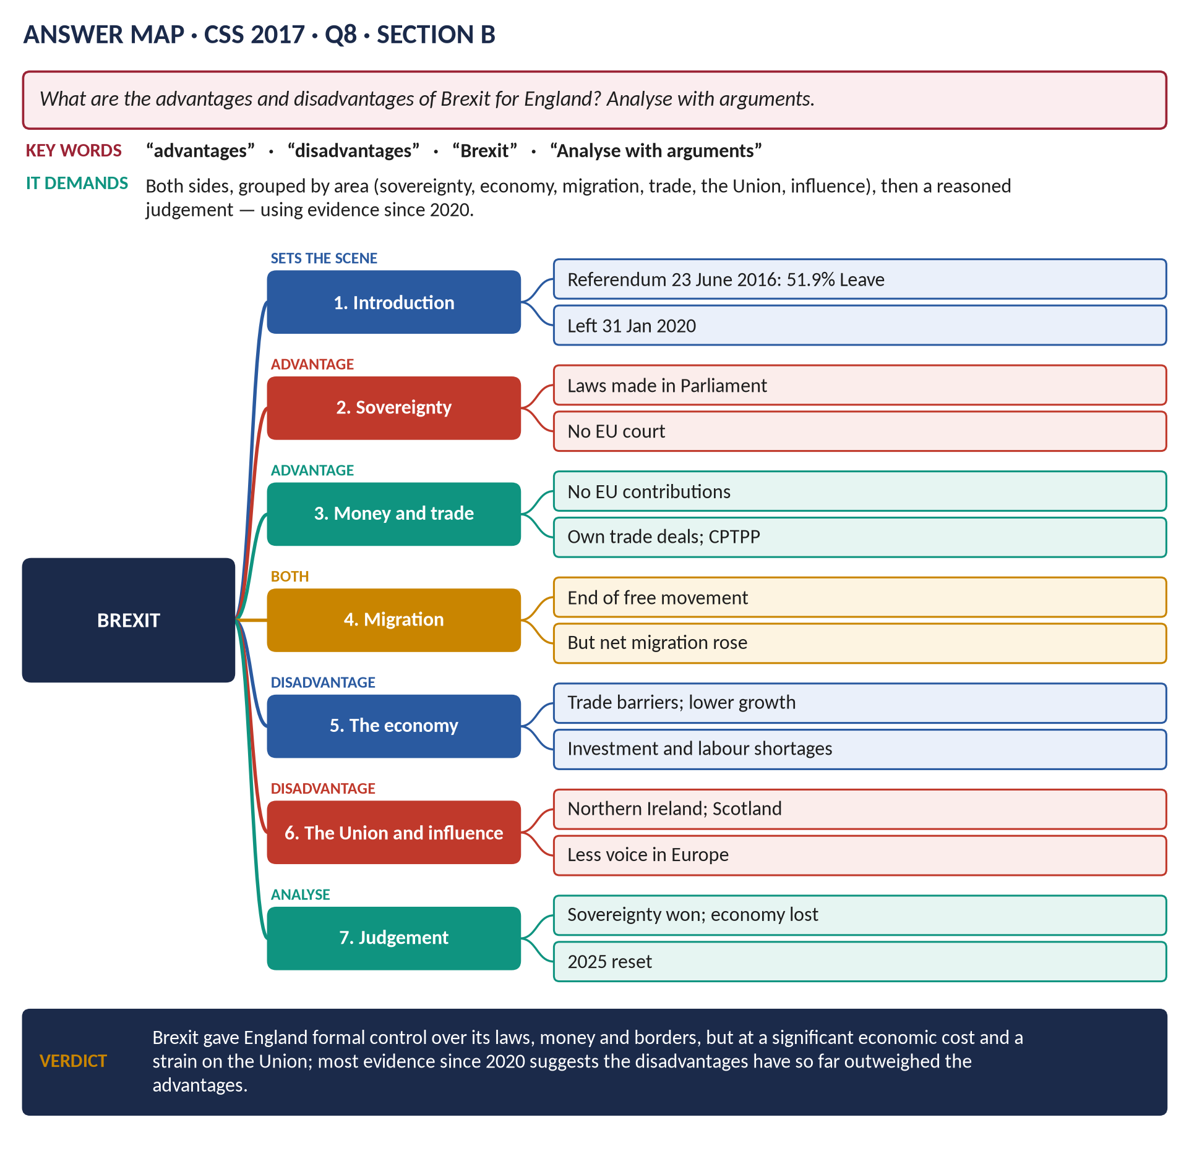
Figure 14 · The answer map for CSS 2017 · Q8 · Section B: every branch is one heading of the answer below.
DECODING THE QUESTION
"What are the advantages and disadvantages of Brexit for England? Analyse with arguments." Set out both sides, grouped by area (sovereignty, money, trade, the economy, immigration, the Union, influence), weigh them with evidence, and give your own reasoned judgement. The question was set in 2017; today you can also use the evidence since 2020. "England" here means the United Kingdom — but note the different effects on Scotland and Northern Ireland.

The model answer

Introduction
On 23 June 2016 the United Kingdom voted by 51.9 per cent to 48.1 per cent to leave the European Union — "Brexit". England (53 per cent Leave) and Wales voted to leave; Scotland and Northern Ireland voted to remain. After years of deadlock Britain left on 31 January 2020. Supporters promised to "Take Back Control" of laws, money and borders; opponents warned of economic damage and a weaker Union. This answer argues that Brexit brought real gains in formal sovereignty and policy freedom, but that the evidence so far shows significant economic costs and strains on the Union — so that, on balance, the disadvantages have outweighed the advantages.
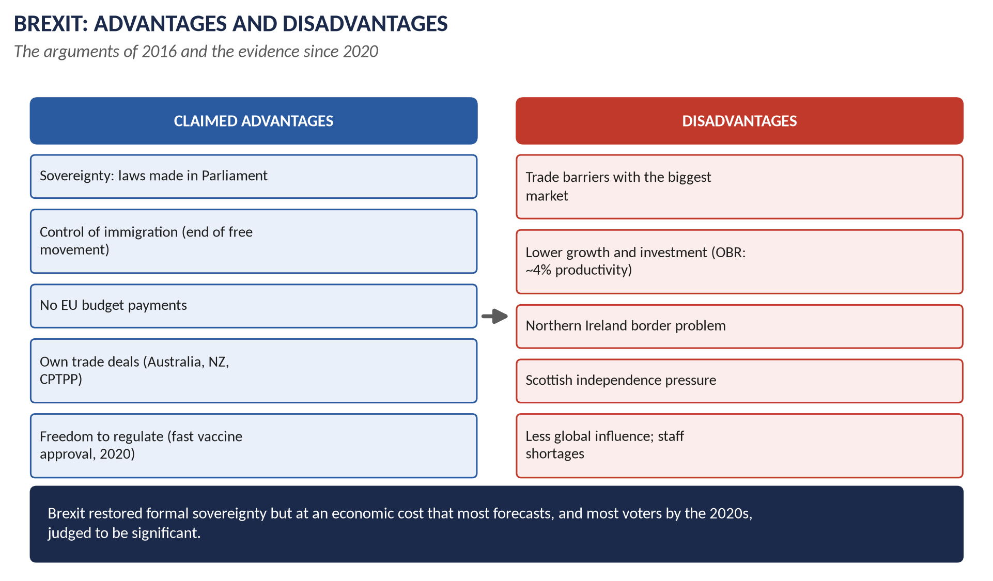
Figure 15 · Brexit: advantages and disadvantages.

The advantages

(1) Sovereignty and democracy
- Laws are now made by the UK Parliament, and the European Court of Justice no longer has authority over British law (except in parts of the Northern Ireland arrangements).
- For many voters this was the heart of the matter: accountability to British voters rather than Brussels.

(2) Money
Britain no longer pays an annual net contribution to the EU budget (about £9–10 billion a year before Brexit).

(3) Trade policy
Britain can make its own trade agreements: with Australia and New Zealand (2021–23), membership of the CPTPP (the Pacific trade bloc, 2024–25), a deal with India (2025), and a tariff deal with the USA (2025).

(4) Regulatory freedom
- Britain can set its own rules. The Covid vaccine was approved first in the world (December 2020).
- Freedom to design rules for new technology (AI, gene editing), financial services and state aid.

(5) Immigration
Free movement from the EU ended; a points-based immigration system (2021) gives the government control over who comes.

(6) Agriculture and fishing
Britain left the Common Agricultural Policy and Common Fisheries Policy and can design its own farm subsidies (paying for environmental "public goods").

The disadvantages

(7) Trade with Europe
- The EU is Britain's largest market (about 40 per cent of exports). The Trade and Cooperation Agreement (2020) avoided tariffs, but introduced customs checks, rules-of-origin paperwork and regulatory barriers.
- The Office for Budget Responsibility estimates that trade will be about 15 per cent lower in the long run than if Britain had stayed.

(8) The economy
- The OBR estimates long-run productivity about 4 per cent lower; business investment stagnated after 2016.
- Small firms found exporting to the EU harder; some moved operations abroad.
- The City lost its "passporting" rights; some jobs moved to Dublin, Paris, Frankfurt and Amsterdam.

(9) Immigration — an unexpected result
- EU migration fell, but labour shortages appeared (lorry drivers, care workers, hospitality, farming).
- Net migration actually rose to record levels (about 900,000 in 2022–23), mainly from outside the EU — so the promise of lower immigration was not met.

(10) The Union
- Northern Ireland: avoiding a hard border with the Irish Republic required a customs border in the Irish Sea (the Protocol, later the Windsor Framework, 2023) — angering unionists; power-sharing collapsed (2022–24).
- Scotland: having voted 62 per cent to remain, it saw renewed demands for independence.

(11) Influence and other losses
- Britain lost its voice in EU decisions and its role as America's "bridge" to Europe.
- It left the Erasmus student exchange (replaced by the Turing scheme) and was out of the Horizon science programme until 2024.
- Travel and work in the EU became harder for British citizens.

Analysis
Area | Advantage | Disadvantage
Sovereignty | Parliament supreme; no ECJ | Must follow EU rules to trade, with no say
Money | No EU contribution | Lower growth reduces tax revenue far more
Trade | New deals (CPTPP, India) | EU trade barriers outweigh new deals
Economy | Regulatory freedom | Productivity −4%; weak investment
Migration | Control; end of free movement | Shortages; net migration higher
Union | — | Northern Ireland; Scotland
Influence | Independent voice (Ukraine) | Less weight in Europe and the world

- Opinion: by the early 2020s most polls showed a majority thought leaving was the wrong decision.
- The reset: the Starmer government's UK–EU summit (May 2025) sought closer cooperation on defence, food standards and youth mobility — an admission that the economic costs needed reducing.
VERDICT · Conclusion
Brexit gave England and the United Kingdom real advantages in sovereignty, control of EU migration, freedom to make trade deals and to regulate, and an end to EU budget payments. But the evidence since 2020 shows that these gains have been outweighed by the disadvantages: new barriers to trade with Britain's largest market, lower productivity and investment, labour shortages, strains on the Union in Northern Ireland and Scotland, and reduced influence. Brexit restored formal control at a significant economic and political cost — which is why even a government committed to it has sought a "reset" with Europe.

WHY THIS ANSWER SCORES · Why this answer scores
Both sides fully argued and grouped by area · evidence from both before and after 2020 (OBR, net migration, CPTPP, Windsor Framework) · a comparison table that weighs each area · a clear, reasoned judgement as "analyse with arguments" requires.

Short Notes

Reforms under David Cameron (also 2025 Q8(c))
THE QUESTION · CSS 2024 · Q7(b) · Section B · short note (10 marks)
Write a short note on: Reforms under David Cameron

David Cameron was Prime Minister from 2010 to 2016 — in coalition with the Liberal Democrats (2010–15), then with a Conservative majority.
- Economy and austerity: deficit reduction (Chancellor George Osborne); VAT to 20 per cent (2011); spending cuts.
- Welfare: the Welfare Reform Act (2012) — Universal Credit; the benefit cap (2013); the tax-free allowance raised to £11,000; the National Living Wage (April 2016).
- Pensions: the triple lock; automatic enrolment in workplace pensions (2012); pension freedoms (2015).
- Education: the Academies Act (2010) — academies and free schools; Michael Gove's curriculum and exam reforms; the pupil premium (2011); university fees up to £9,000 (2012).
- Health: the Health and Social Care Act (2012).
- Society: same-sex marriage (2013); the Modern Slavery Act (2015); overseas aid at 0.7 per cent made law (2015); the "Big Society".
- Constitution: the Fixed-term Parliaments Act (2011); the AV referendum (2011, rejected); the Scottish independence referendum (2014, 55.3 per cent No) and new powers for Scotland; English Votes for English Laws (2015); recall of MPs; the EU referendum (2016).
In one line: austerity and welfare reform combined with social liberalism and constitutional change — ending with the referendum that ended his premiership.

Britain's Role in the War on Terror
THE QUESTION · CSS 2026 · Q8(a) · Section B · short note (10 marks)
Write a short note on: Britain's role in the War on Terror

- Solidarity: after 9/11 (11 September 2001) Tony Blair pledged to stand "shoulder to shoulder" with the USA and became its closest ally.
- Afghanistan (2001–2021): British forces helped overthrow the Taliban (2001); led the first ISAF force; fought in Helmand (2006–14); 457 British dead; combat ended 2014; the Taliban returned in August 2021.
- Iraq (2003–2009): Blair argued Saddam had WMD (the September 2002 dossier); won a Commons vote (412–149); about 46,000 troops invaded (20 March 2003); Britain held Basra; 179 British dead; no WMD found; the Chilcot Report (2016) criticised the decision and planning.
- At home: anti-terror laws (2000, 2001, 2005, 2006); detention without trial (Belmarsh) and control orders; the 7/7 bombings (2005, 52 killed); the Prevent strategy.
- Intelligence: close cooperation through the Five Eyes; but complicity in rendition and mistreatment was later admitted.
- Later: air strikes against ISIS in Iraq (2014) and Syria (2015).
- Consequences: a closer special relationship but "poodle" criticism; damaged trust; the "Iraq syndrome" (Syria vote, 2013).
In one line: America's chief partner in Afghanistan and Iraq — at a heavy cost in lives, trust and reputation.

Lady Diana (also 2026 Q8(b): Lady Diana Spencer)
THE QUESTION · CSS 2018 · Q8(c) · Section B · short note (10 marks)
Write a short note on: Lady Diana

- Born Diana Spencer on 1 July 1961 at Sandringham, daughter of the 8th Earl Spencer.
- Married Prince Charles on 29 July 1981 at St Paul's Cathedral — watched by about 750 million people.
- Sons: Prince William (1982) and Prince Harry (1984).
- Humanitarian work: challenged the stigma of HIV/AIDS (shaking an AIDS patient's hand without gloves, 1987); leprosy; homelessness; children's hospitals; walked through a minefield in Angola (January 1997) — helping the campaign for the Ottawa Treaty banning landmines (December 1997).
- The end of the marriage: separation (1992); her BBC Panorama interview (1995): "There were three of us in this marriage"; divorce (1996).
- Death: killed in a car crash in Paris on 31 August 1997, with Dodi Fayed, while pursued by photographers.
- "The People's Princess" (Tony Blair); an unprecedented outpouring of public grief; criticism of the Queen's response; funeral on 6 September 1997.
- Inquest (2008): unlawful killing through the gross negligence of the driver and the pursuing paparazzi.
- Legacy: a more open and emotional monarchy and public culture; a global humanitarian icon.
In one line: a royal who became a global humanitarian icon, and whose death changed the way the monarchy relates to the public.

Part Two — The Past MCQs, Solved

CSS 2024 · MCQ 10
Which Prime Minister sent British troops to Iraq in 2003?
(A) John Michael | (B) Tony Blair | (C) Johnny Carlos | (D) None of these

REMEMBER · Answer: B. Tony Blair
Tony Blair, the Labour Prime Minister, sent about 46,000 British troops to join the US-led invasion of Iraq in March 2003.

CSS 2025 · MCQ 15
Which party governed under Tony Blair?
(A) Conservative Party | (B) Labour Party | (C) Liberal Democrats | (D) None of these

REMEMBER · Answer: B. Labour Party
Tony Blair led the Labour Party (as "New Labour") and was Prime Minister from 1997 to 2007.

CSS 2025 · MCQ 18
The global economic downturn beginning in 2008 is generally called the:
(A) Great Depression | (B) Financial Crisis | (C) Oil Crisis | (D) None of these

REMEMBER · Answer: B. Financial Crisis
The downturn that began in 2007–08 is generally called the (global) Financial Crisis; the Great Depression was in the 1930s.

CSS 2025 · MCQ 20
David Cameron formed which type of government in 2010?
(A) Majority government | (B) Coalition government | (C) Minority government | (D) None of these

REMEMBER · Answer: B. Coalition government
After the hung parliament of May 2010, David Cameron formed a coalition government with the Liberal Democrats.

CSS 2026 · MCQ 11
The Good Friday Agreement addressed conflict in:
(A) Wales | (B) Northern Ireland | (C) Scotland | (D) None of these

REMEMBER · Answer: B. Northern Ireland
The Good Friday Agreement (10 April 1998) addressed the conflict in Northern Ireland, creating power-sharing government.

CSS 2026 · MCQ 12
The London 7/7 bombings occurred in:
(A) 2003 | (B) 2004 | (C) 2008 | (D) None of these

REMEMBER · Answer: D. None of these — 2005
The 7/7 bombings in London took place on 7 July 2005 — none of the listed years, so the key is "None of these".

CSS 2026 · MCQ 13
The 2010 coalition government joined the Conservatives with:
(A) Labour | (B) Scottish National Party | (C) Liberal Democrats | (D) None of these

REMEMBER · Answer: C. Liberal Democrats
The 2010 coalition joined the Conservatives with the Liberal Democrats (Nick Clegg).

CSS 2026 · MCQ 20
The 2010–15 coalition government was led by:
(A) David Cameron | (B) Nick Clegg | (C) Ed Miliband | (D) None of these

REMEMBER · Answer: A. David Cameron
The 2010–15 coalition was led by David Cameron as Prime Minister, with Nick Clegg as his deputy.

Part Three — Five Predicted Questions, with Outlines
WHAT THE EXAMINER HAS ASKED · Why these five
They cover major themes of contemporary Britain not yet set as full questions.

Predicted 1 · "Assess the significance of devolution and the Good Friday Agreement for the United Kingdom."
- Devolution (1997–99): Scotland, Wales, London; later powers (2012, 2016).
- The Good Friday Agreement (1998): power-sharing; consent; north–south bodies; decommissioning; suspensions; restored 2024.
- Significance: peace; a quasi-federal UK; the English question; the SNP and 2014; Brexit's strains.

Predicted 2 · "Evaluate the Blair government's domestic record, 1997–2007."
- Economy: Bank independence; growth; light regulation.
- Services: NHS and schools investment; targets; PFI.
- Poverty: minimum wage; tax credits; Sure Start.
- Constitution: devolution, HRA, FOI, Lords.
- Limits: inequality; debt; Iraq's shadow.

Predicted 3 · "Why did Britain vote to leave the European Union in 2016?"
- Long-term Euroscepticism (Maastricht; UKIP); immigration after 2004; austerity and the "left behind"; sovereignty; distrust of elites; the campaigns ("Take Back Control"); Cameron's gamble.

Predicted 4 · "Discuss the political instability in Britain from 2016 to 2024."
- Brexit deadlock (May); Johnson's majority; Covid and partygate; Truss's mini-budget; Sunak; five PMs in eight years; causes and consequences; Labour's 2024 landslide.

Predicted 5 · "How did the Covid-19 pandemic affect British politics and society?"
- Lockdowns; furlough; vaccines; deaths; inequality; debt; partygate; the public inquiry; long-term effects on health, education and the economy.

